Lidar Measurement outside: (10_16_2020)

10/16/20

new board 3A.

Both laser and detector are wrapped with Al foil.

134= laser open, (both room light on), distance Long (with reflector).

Outside

135= laser open, (outside Shelby quad, moving) See video.

136= laser open, (outside Shelby quad, moving) See video.

137= laser open, (NERC basement, static, target long wall) See video.

138= laser open, (NERC basement, moving towards the target long wall) See video.

139= laser open, (NERC basement, moving perpendicular to laser, hitting pillar near the wall) See video.

140= laser open, (NERC basement, moving perpendicular to laser, hitting pillar far from the wall) See video.

Measured distance (approximately):

distance: run 137= (12*12)ft = 144 ft = 43.8912 m

run 140 = 131 inch = 3.3274 m (up to nearest pillar)

run 140 = (144+86)inch = 5.842 m (up to nearest side wall, last section of video)

run 140 = ((4*144)+143) = 719 inch = 18.2626 m (up to farthest side wall, first section of video)

**Inside the lab just before going out:**

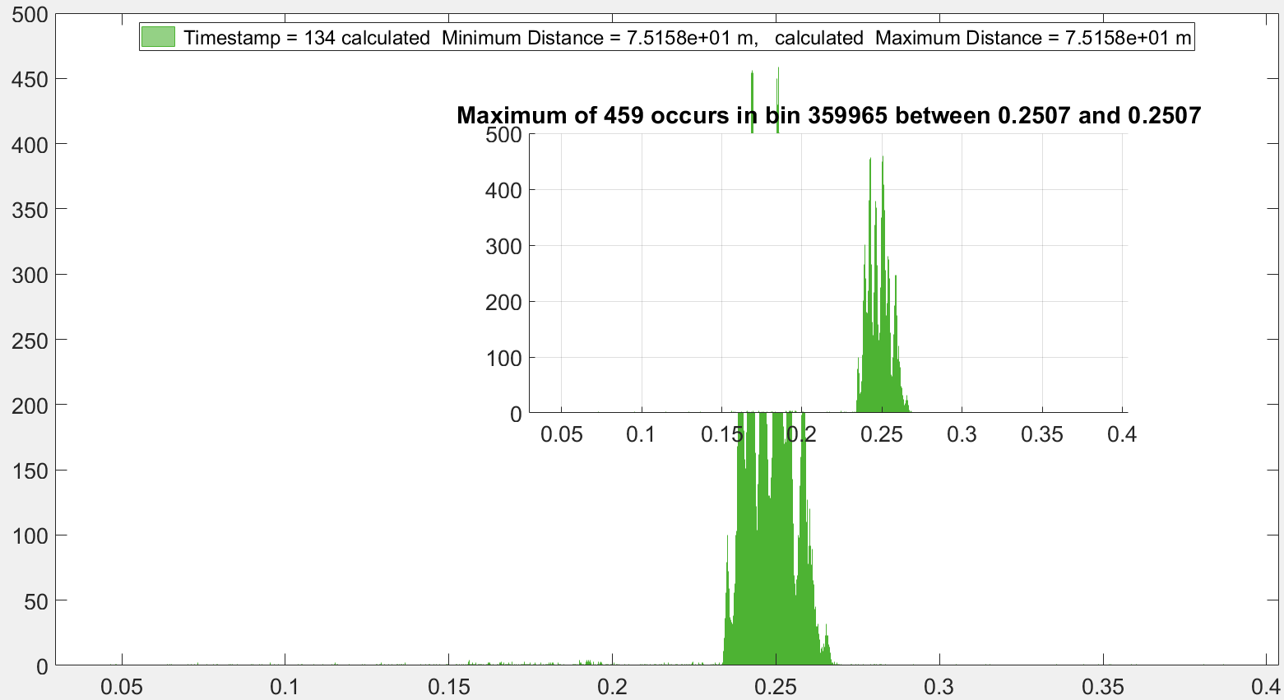

**(Shelby basement static poison facing towards wall)**

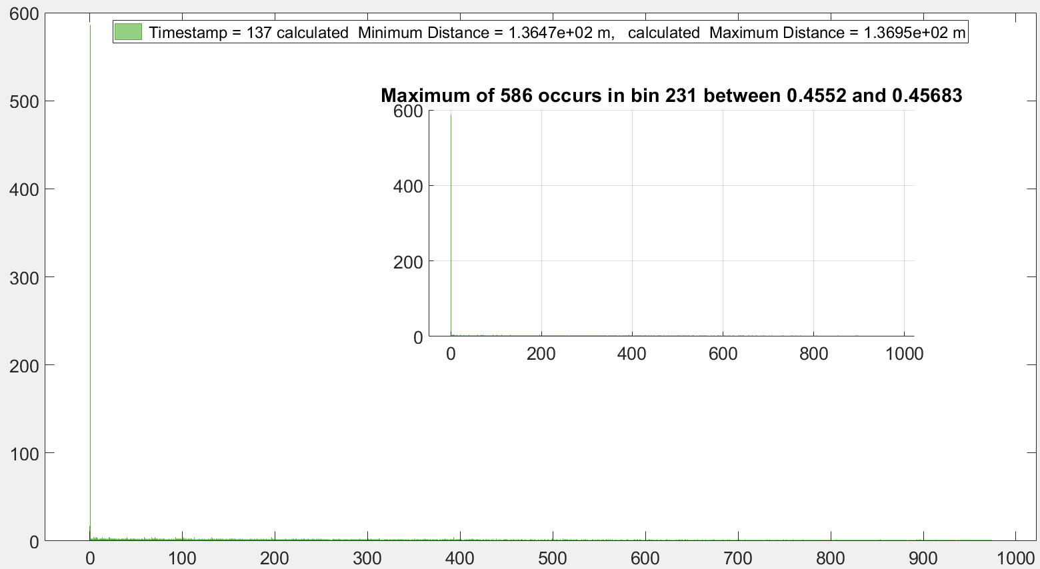

If we zoomed in run 137

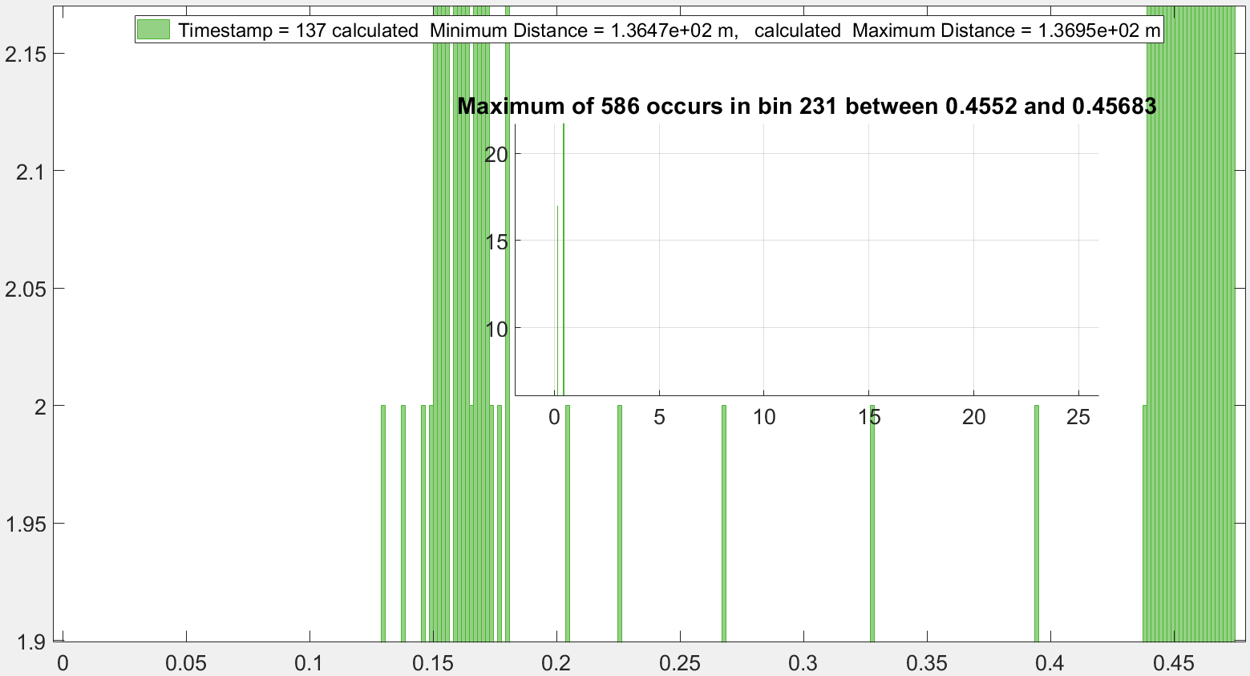

In run 137 if we ignore the counts say after 400 ns we can clearly see the detector is getting photon from laser firing from inside the box.

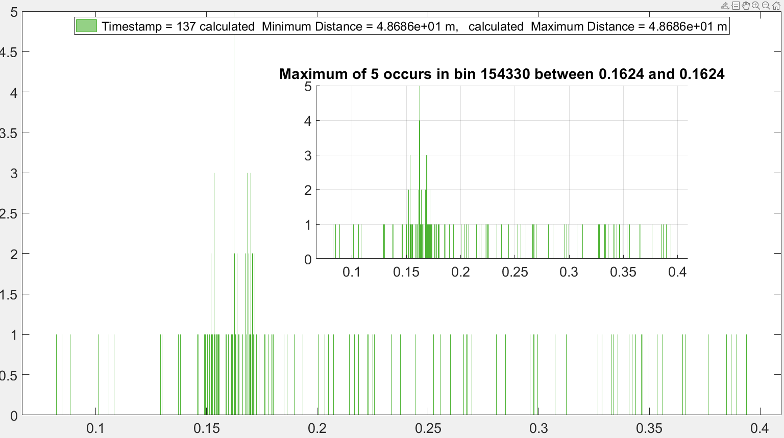

So from this two histogram:

TDC start distance: 48.686 m

Wall distance (calculated): 136.47 m

Total 2 way distance between Lidar and wall: (136.47 – 48.686) m = 87.784 m

Distance between Lidar and wall for run 137 : 43.892 m

Excluding any higher del_t values after 0.5 microsecond run 137:

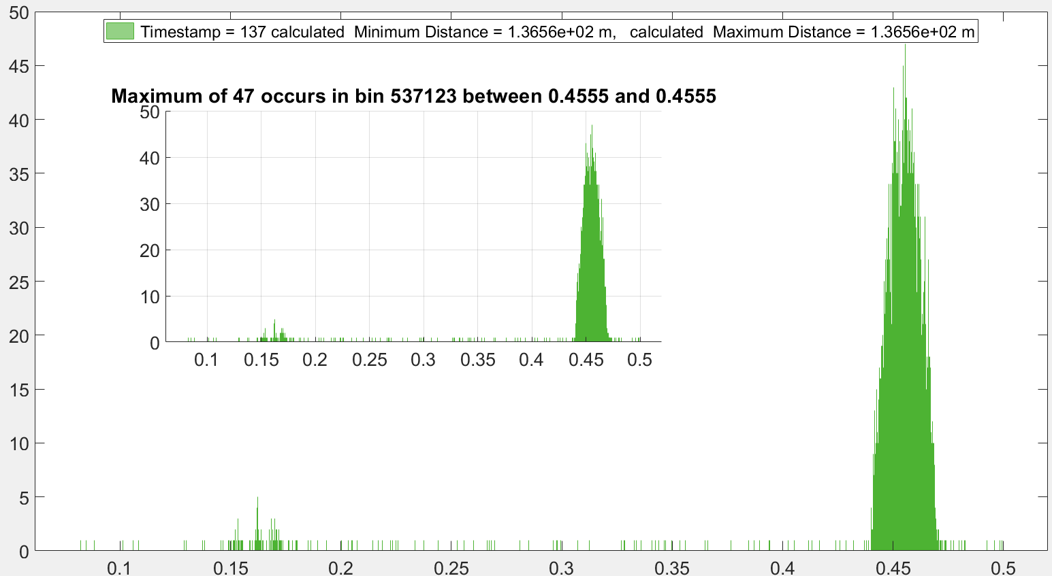

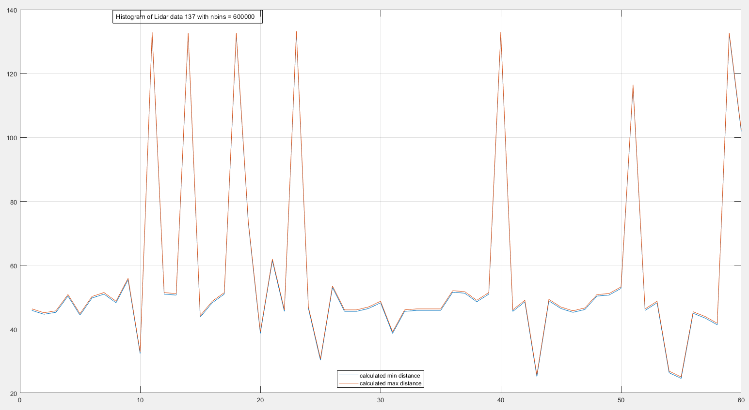

If considered dynamic, platform Run 137, nbins= 600000

Breaking total 60 sec data to 60 timestamp, and calculated distance from probability density from individual 60 histogram

x-axes is time in s

Y-axes is calculated distance in m

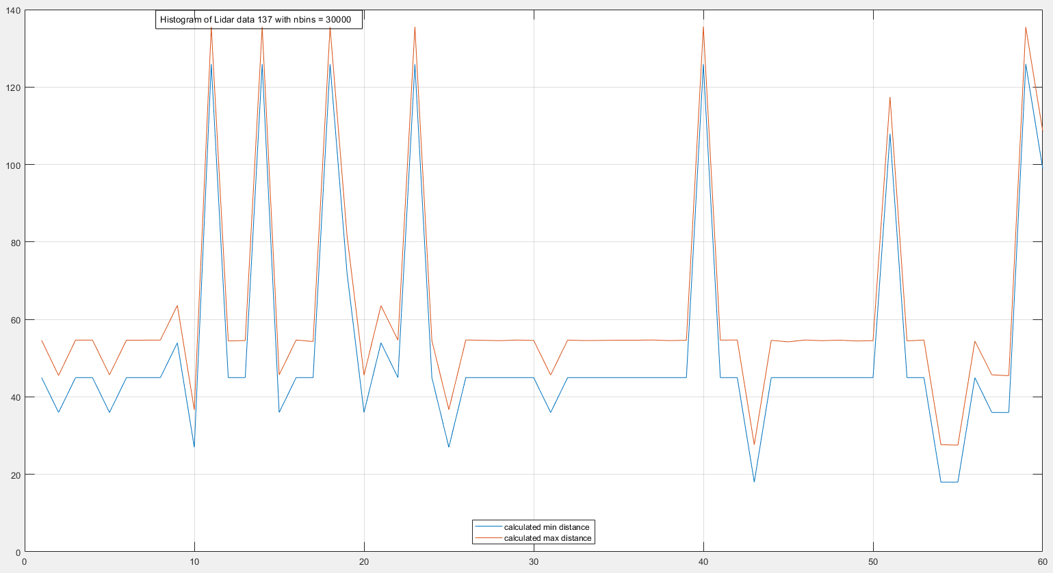

If considered dynamic, platform Run 137, nbins= 300000

Breaking total 60 sec data to 60 timestamp, and calculated distance from probability density from individual 60 histogram

x-axes is time in s

Y-axes is calculated distance in m

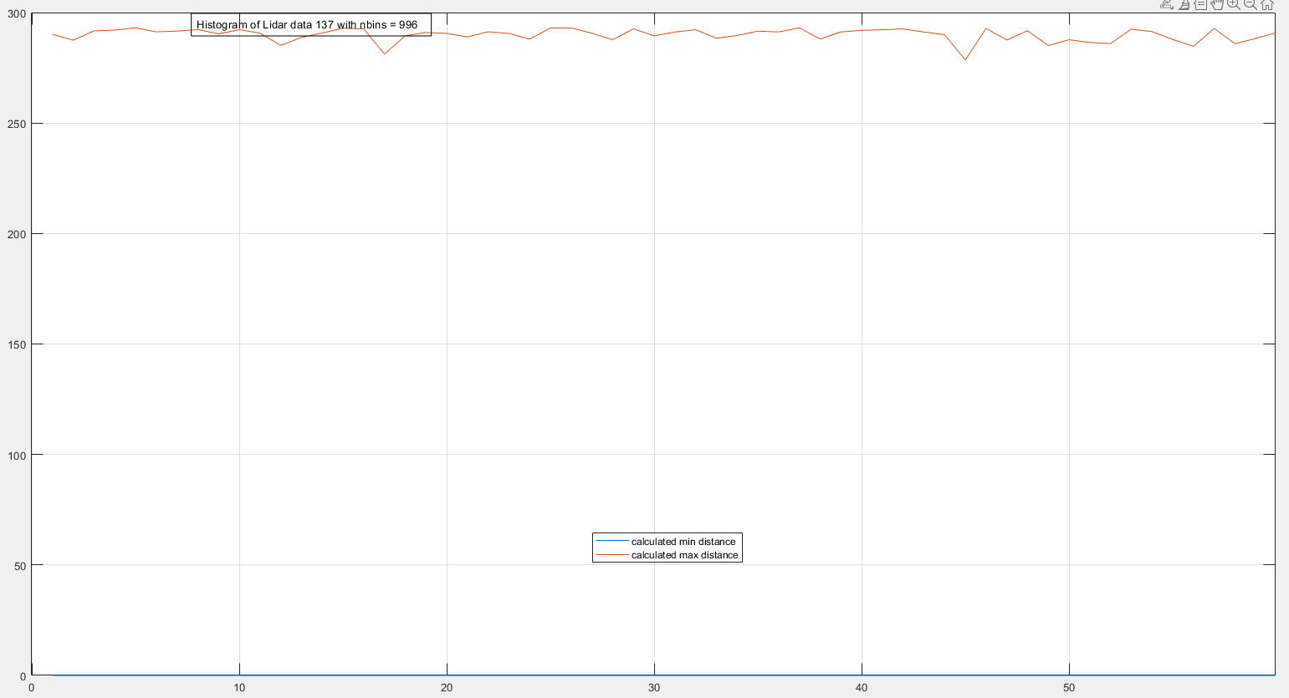

If considered dynamic, platform Run 137, nbins= 996

Breaking total 60 sec data to 60 timestamp, and calculated distance from probability density from individual 60 histogram

x-axes is time in s

Y-axes is calculated distance in m

**Run 140 (dynamic) moving perpendicular to spatially varying target**.

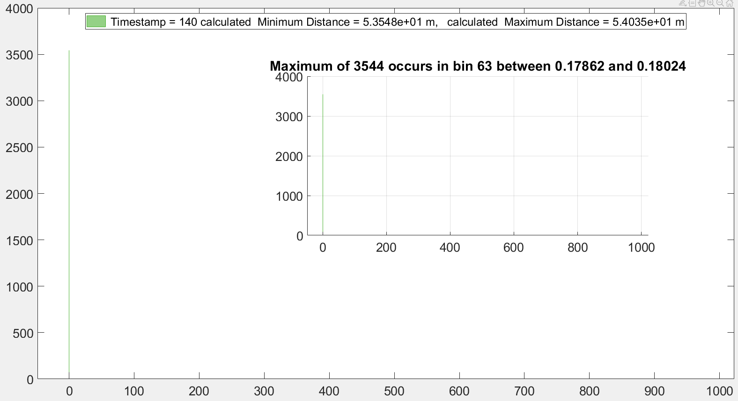

If we zoom in:

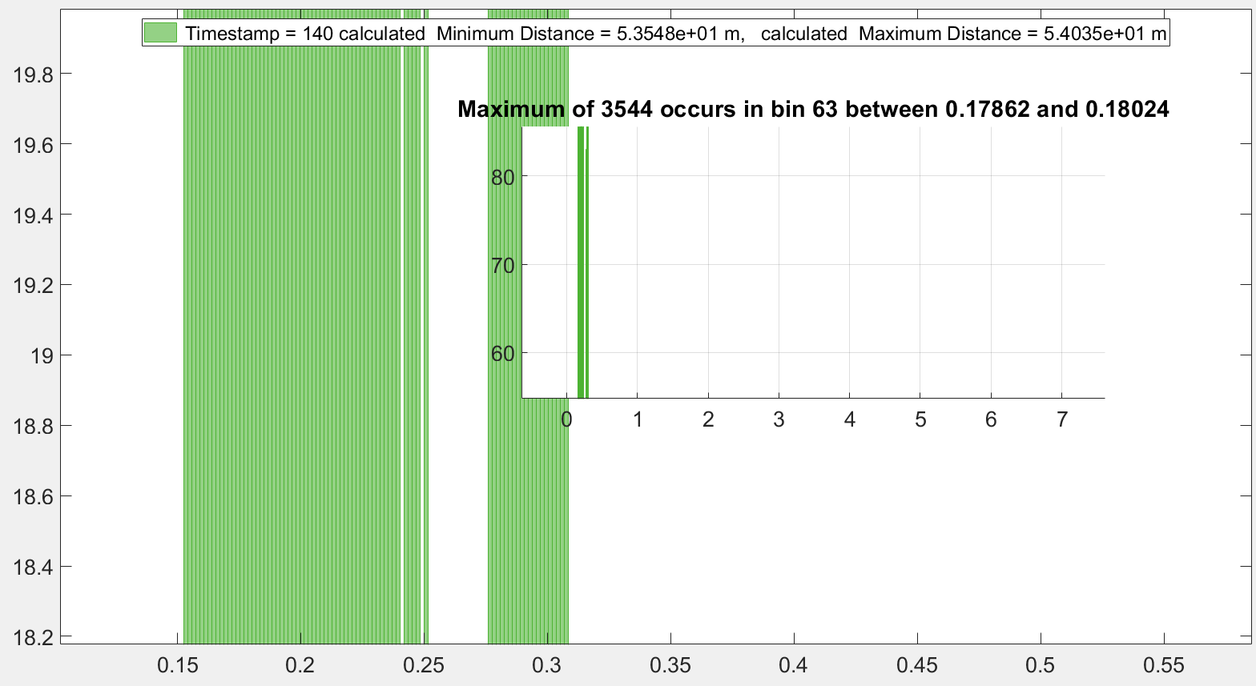

Total 2 way distance between Lidar and pillar: (53.548 – 48.686) m = 4.862 m

Distance between Lidar and pillar: 2.431 m

Total 2 way distance between Lidar and pillar: (54.035 – 48.686) m = 5.349 m

Distance between Lidar and pillar: 2.674 m

This way we see this is not accurate. So it means when we his both long and short distance on dynamic platform then the peak gets broaden. Omitting data of higher del_t run 140:

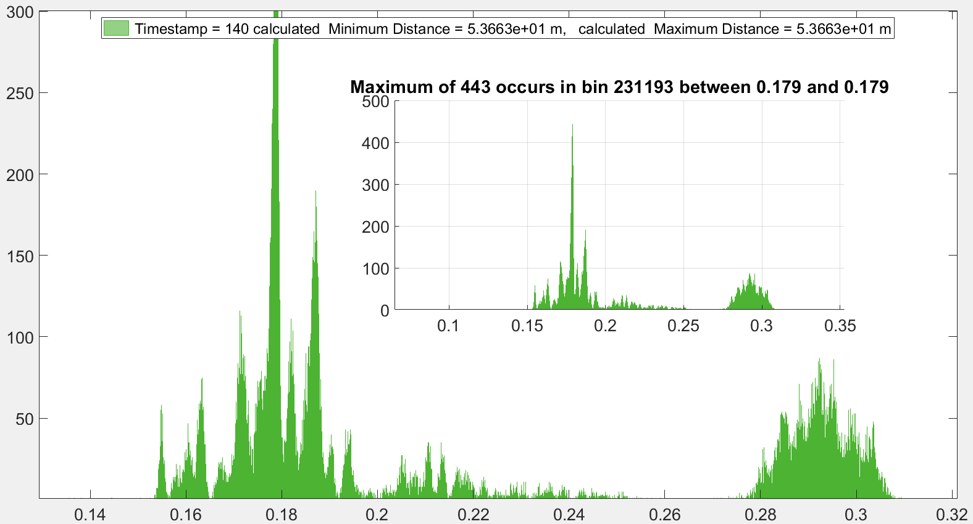

So the 2 way pillar distance could be: at (0.29 -0.15) = 0.14 microsecond * 299.7925 = 41.97095 m

So the 2 way wall distance could be: at (0.178 -0.15) = 0.028 microsecond * 299.7925 = 8.39419 m

Distance between the lidar and pillar for run 140= 20.985475 m

Distance between the lidar and wall for run 140 = 4.197 m

Impression: Distance difference = count difference

43.892m-20.985 m = 586-3544

So adding 22.907m distance we lose 2958 counts.

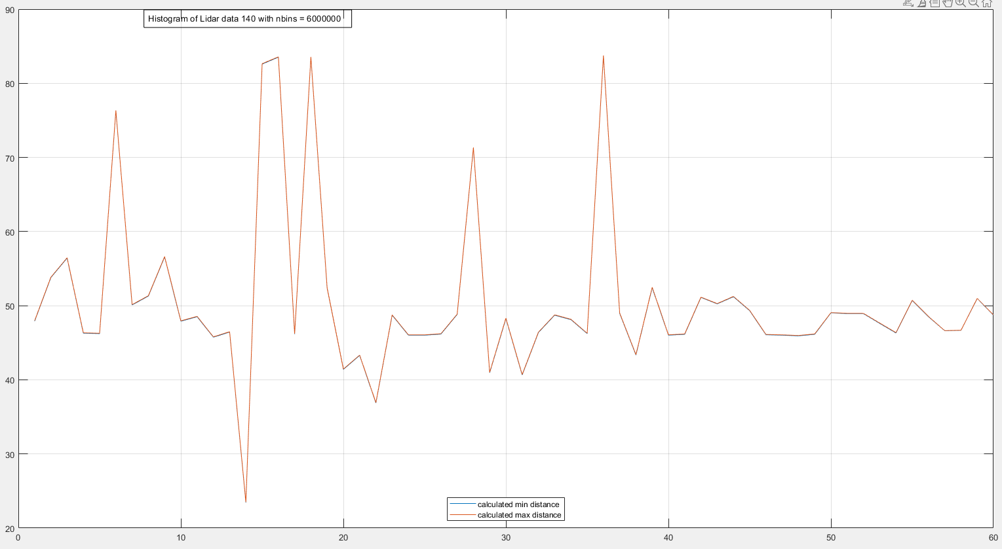

Dynamic, platform Run 140, nbins= 6000000

Breaking total 60 sec data to 60 timestamp, and calculated distance from probability density from individual 60 histogram

x-axes is time in s

Y-axes is calculated distance in m

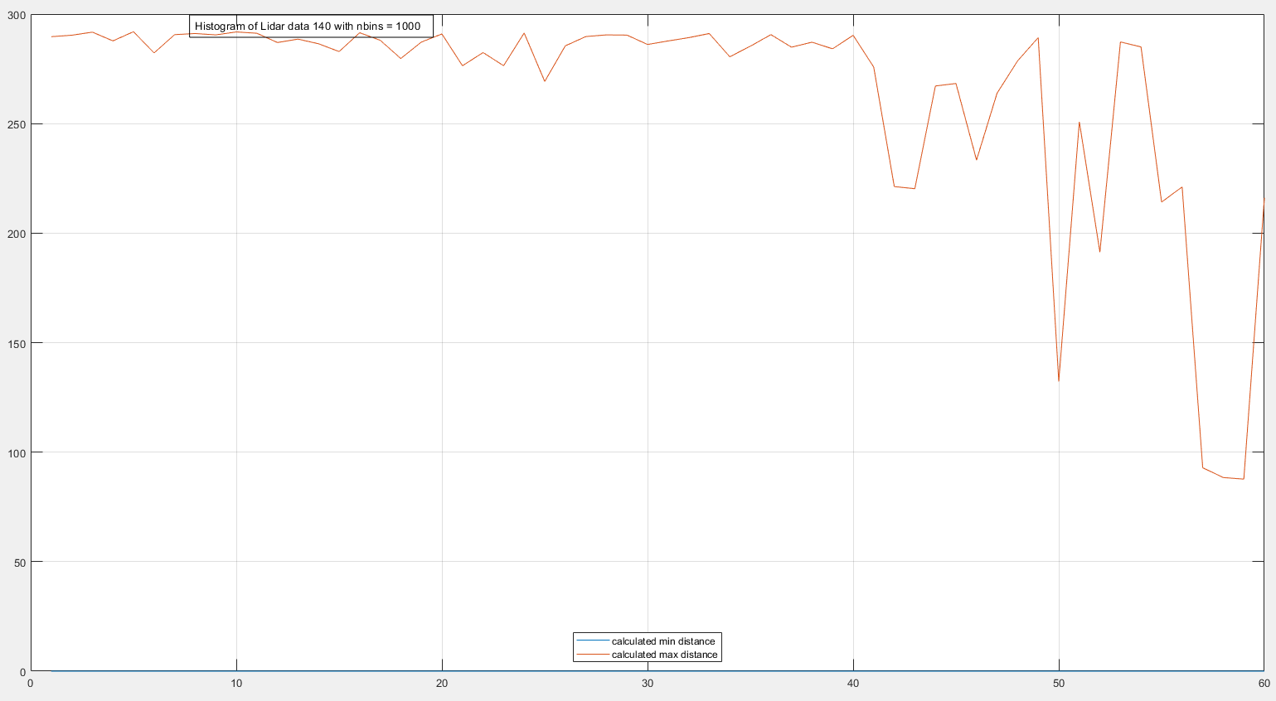

Dynamic, platform Run 140, nbins= 1000

Breaking total 60 sec data to 60 timestamp, and calculated distance from probability density from individual 60 histogram

x-axes is time in s

Y-axes is calculated distance in m

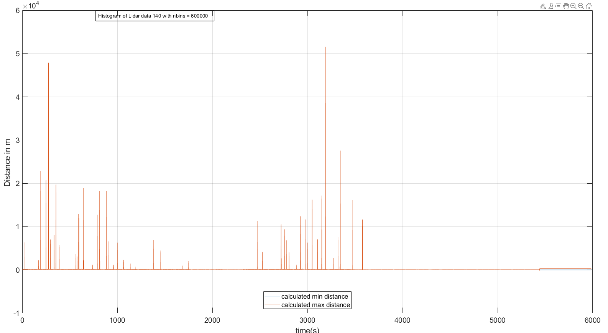

(del_t0)/10)

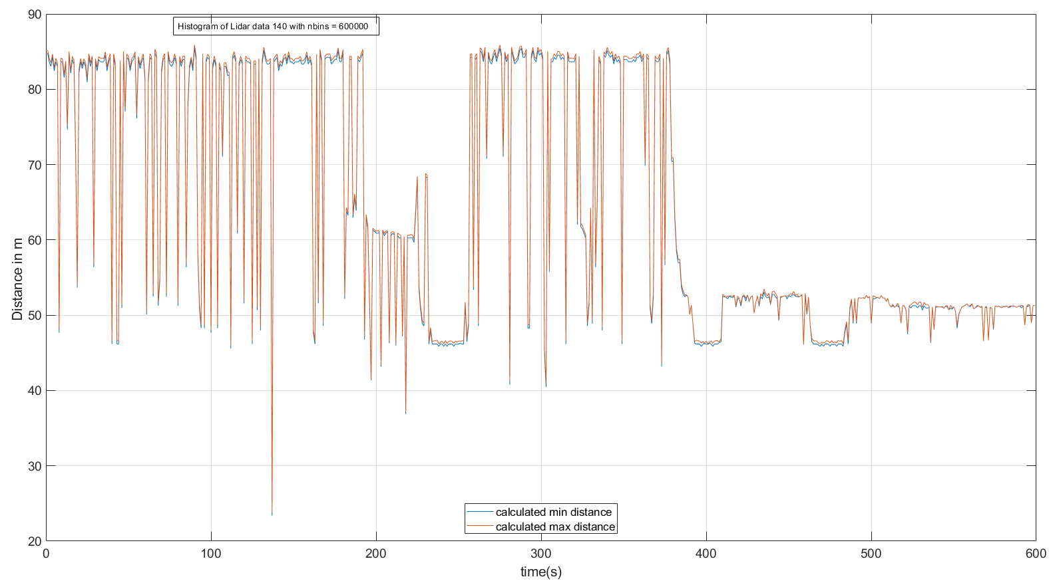

(del_t0)/100)

First it seems for some reason our (detector) or circuit is not recording any data from 4.06 *106 to 4.1 *106 time length which is equivalent to 24.0367 s for the one minute of recording. So there need to be a section of code that will take care all the jumps in at the end of every minutes and hours. So generating linearly increasing time vector.

But then I understood what has happened

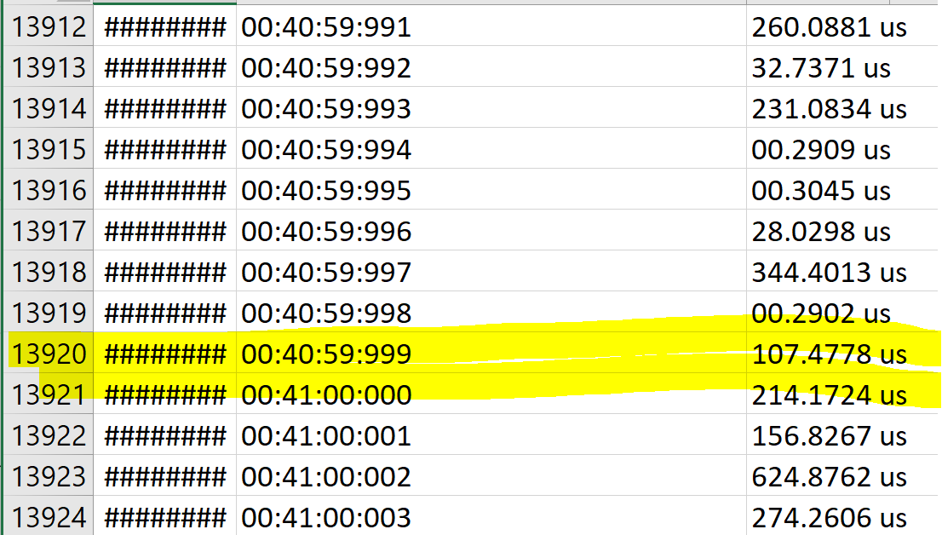

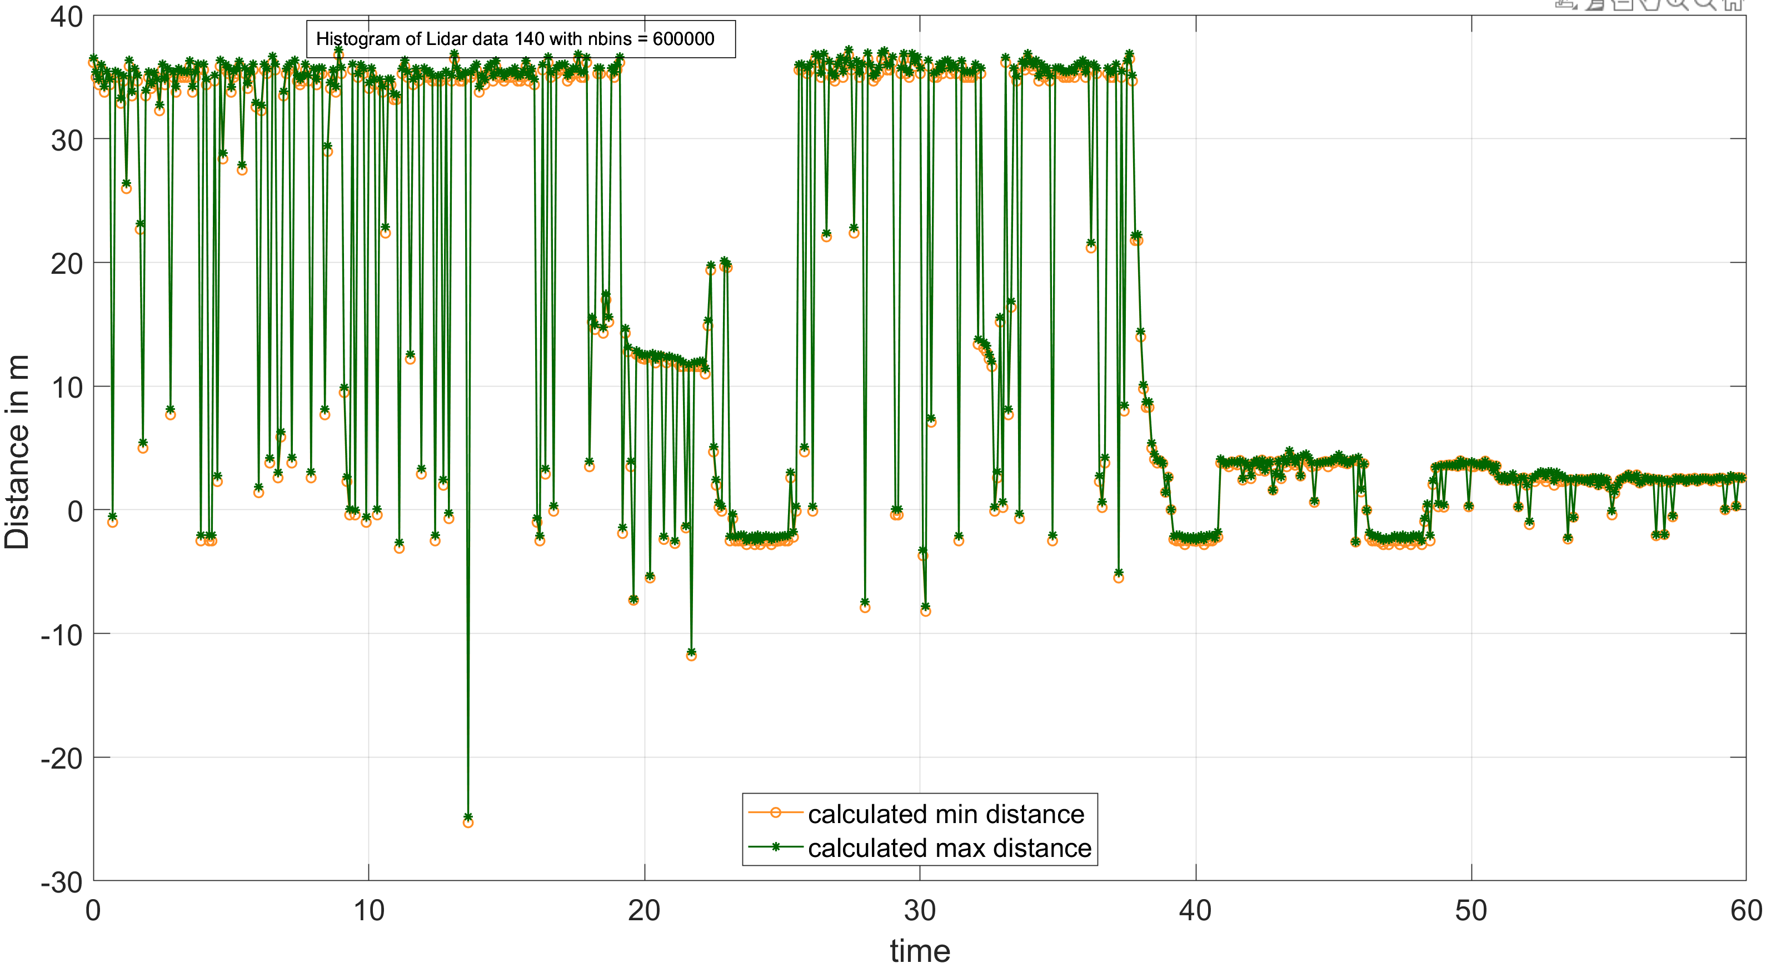

* **Still big question is why distance comes -ve sometime if I subtract the TDC tart time of detection of the internal reflection of laser from inside the box that is 0.1624 microsecond from the max probable count of histogram**

**Summary and graph after optimization of the code:**

**Here static graphs are 2 way distance without TDC start timing correction.**

**Dynamics graphs are 1 way distance with TDC start timing correction**

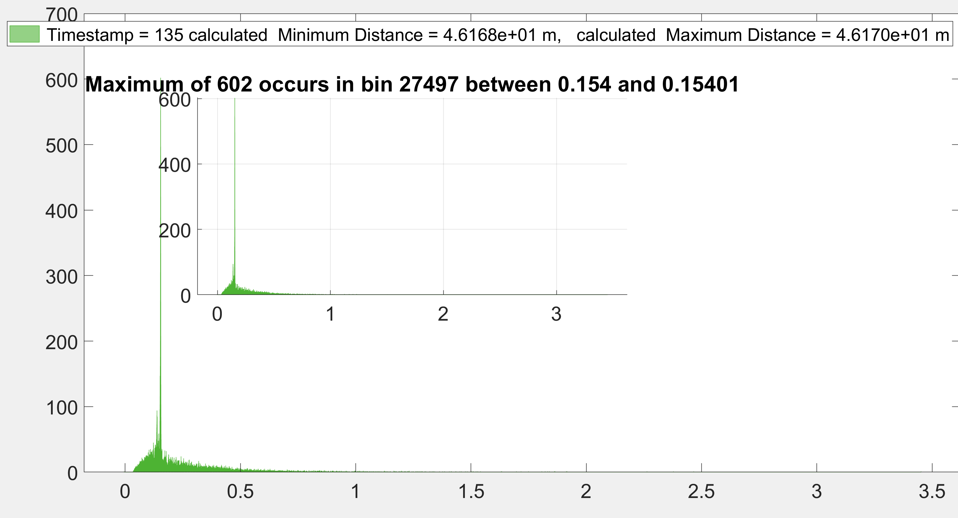

**After zooming**

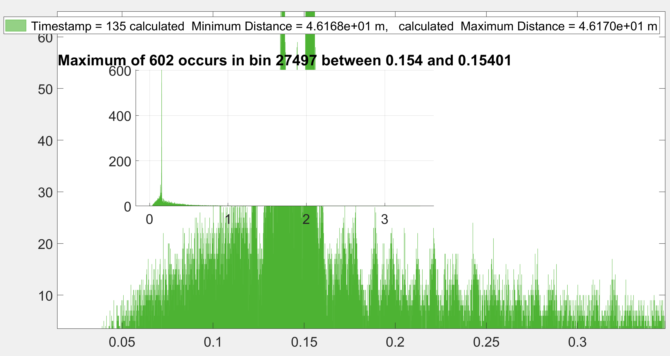

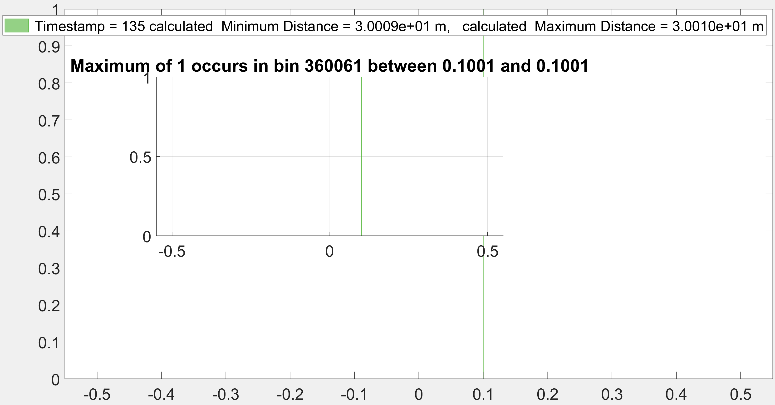

Omitting data after 0.3 microsec.

**After zooming**

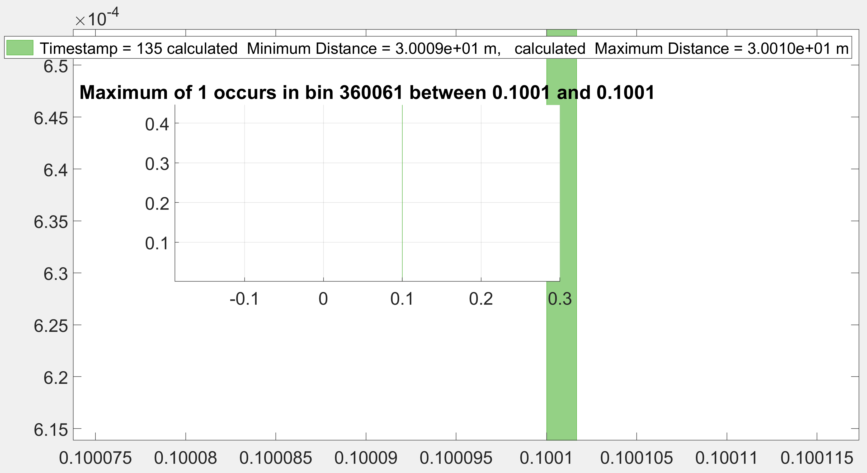

**For whatever reason this run does not detect anything in short time say 0.3 microsecond and starts quite early (0.1154 microsec) not the TDC start time 0.1624 microsec. This could be complicated condition of outdore measurement.**

**Please see the video (1st one of Shelby quad (dynamic).**

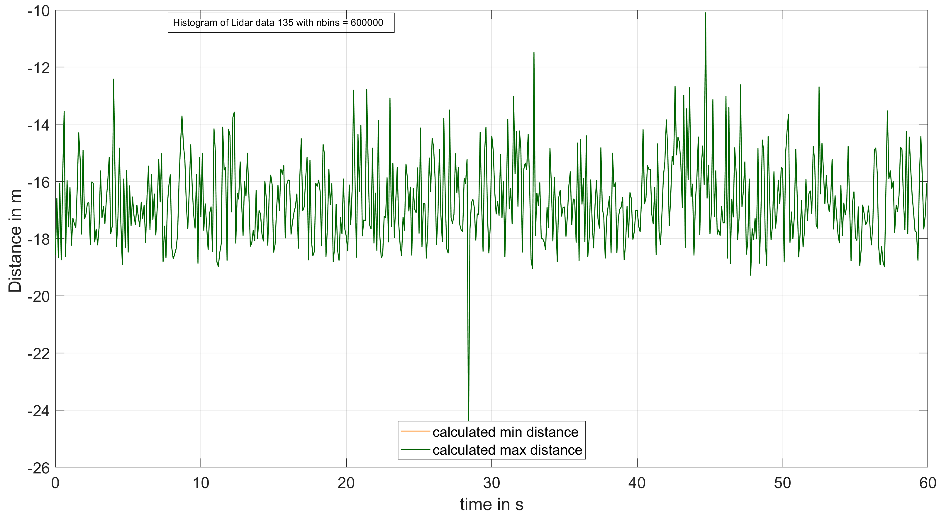

(del_t0)/100)

135

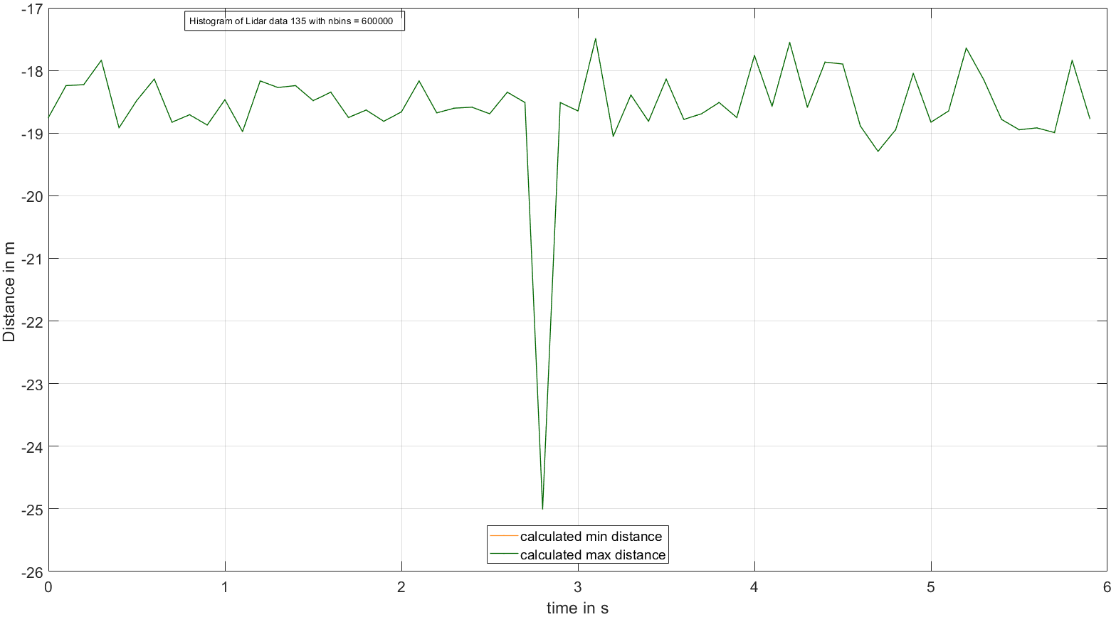

(del_t0)/1000)

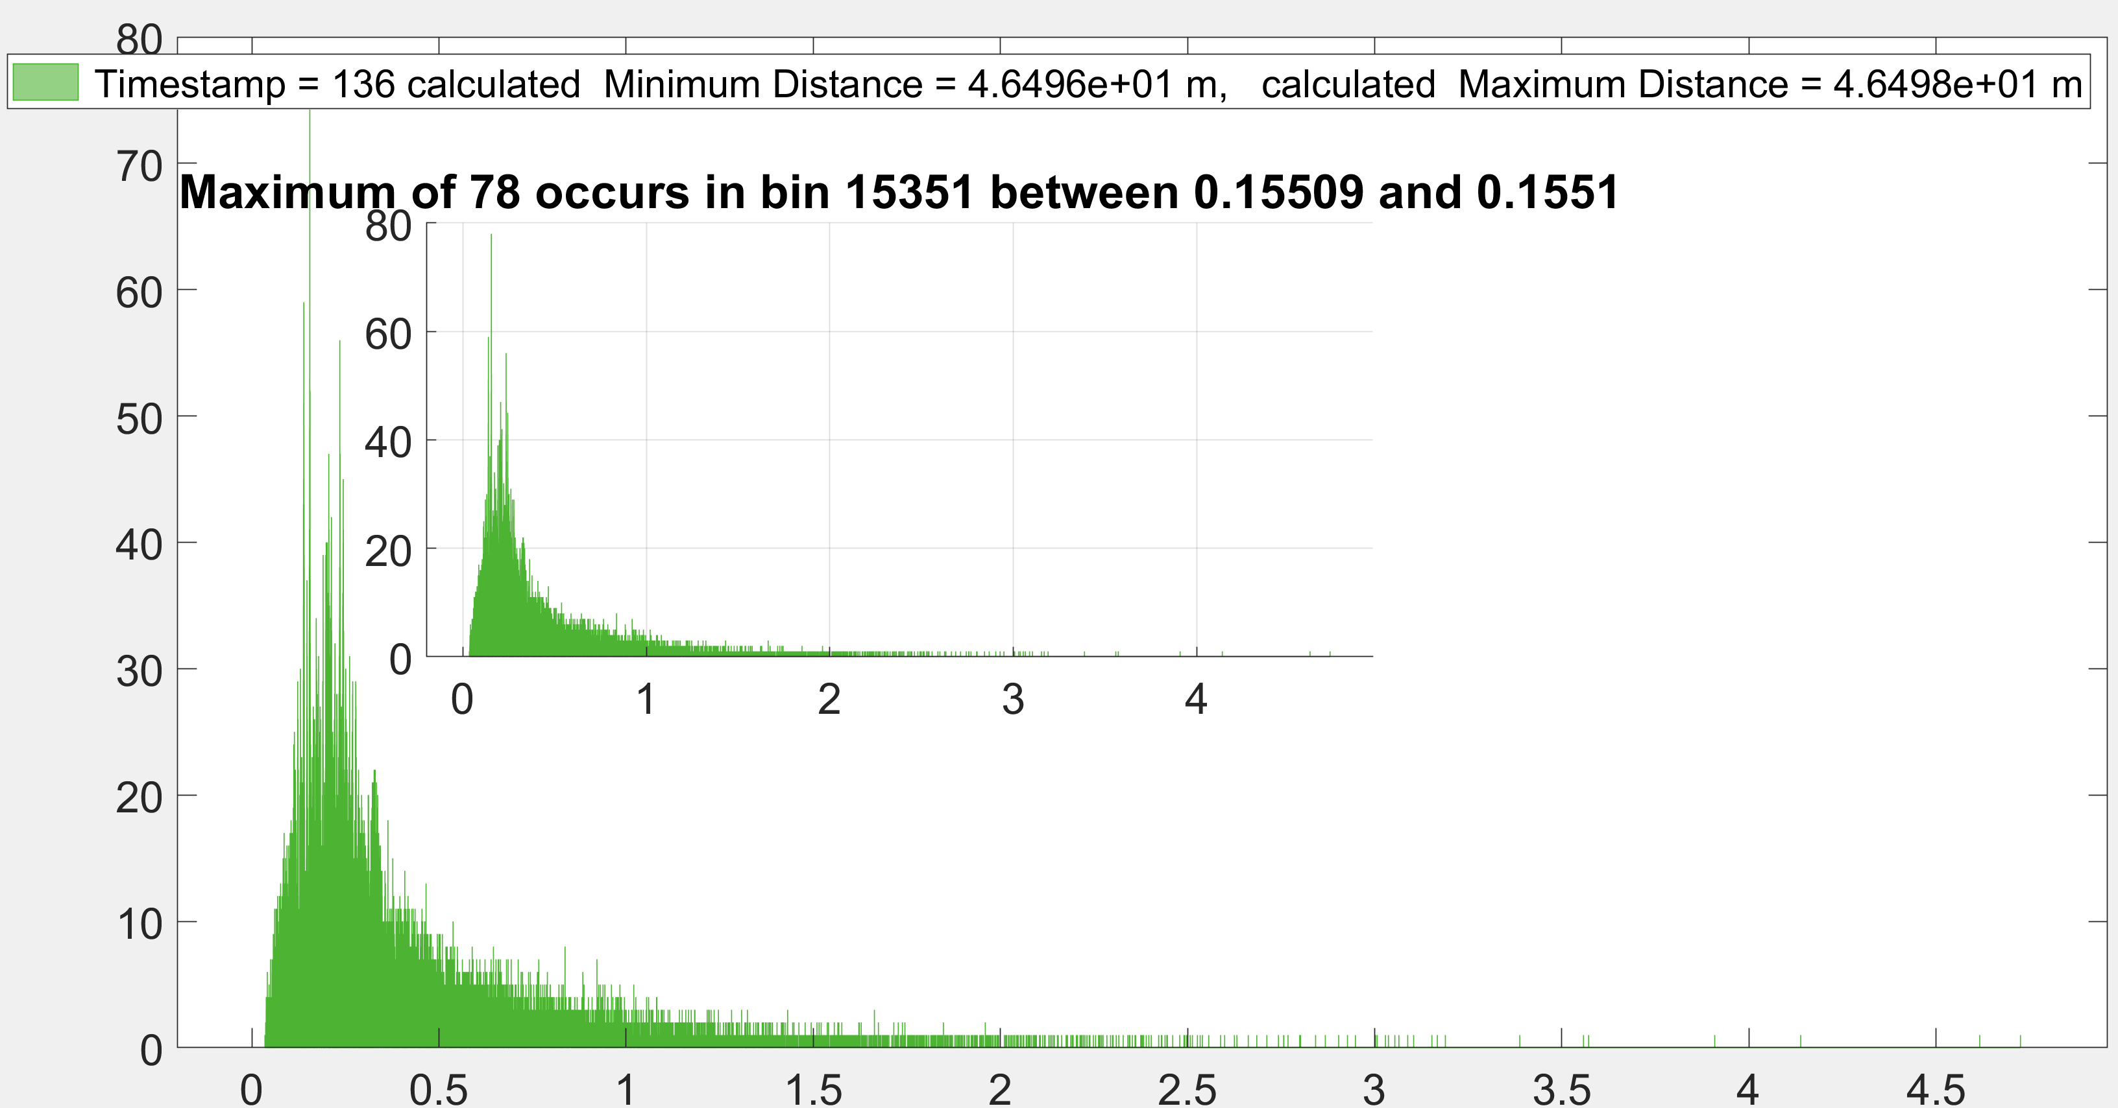

**This also starts early at 0.551 microsec. Please see the video (3rd one of Shelby quad (dynamic)).**

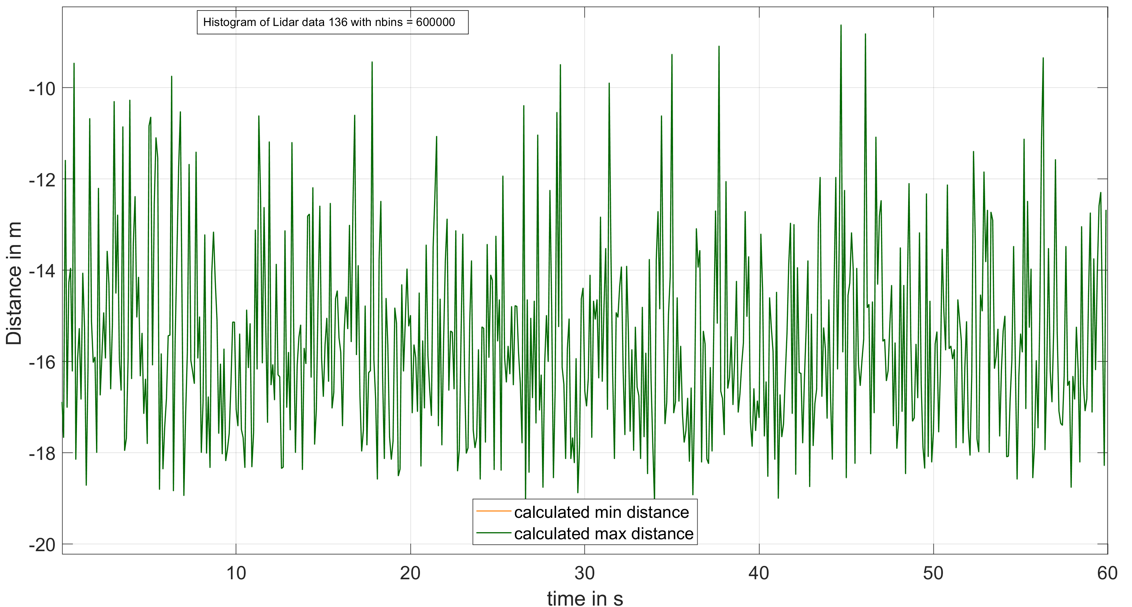

(del_t0)/100)

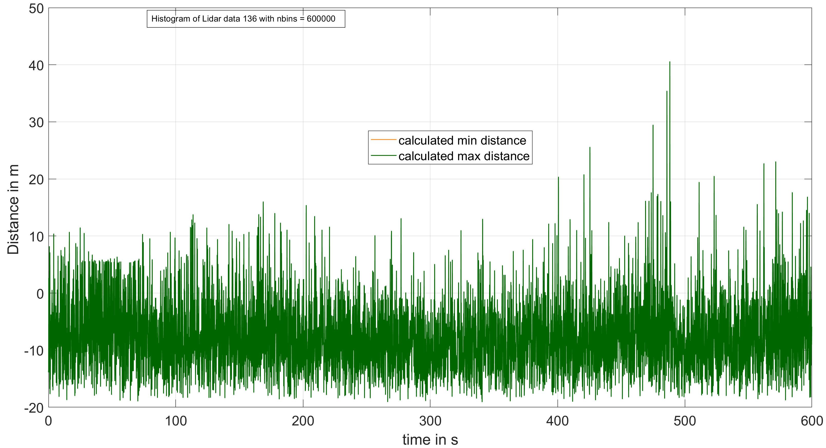

(del_t0)/10)

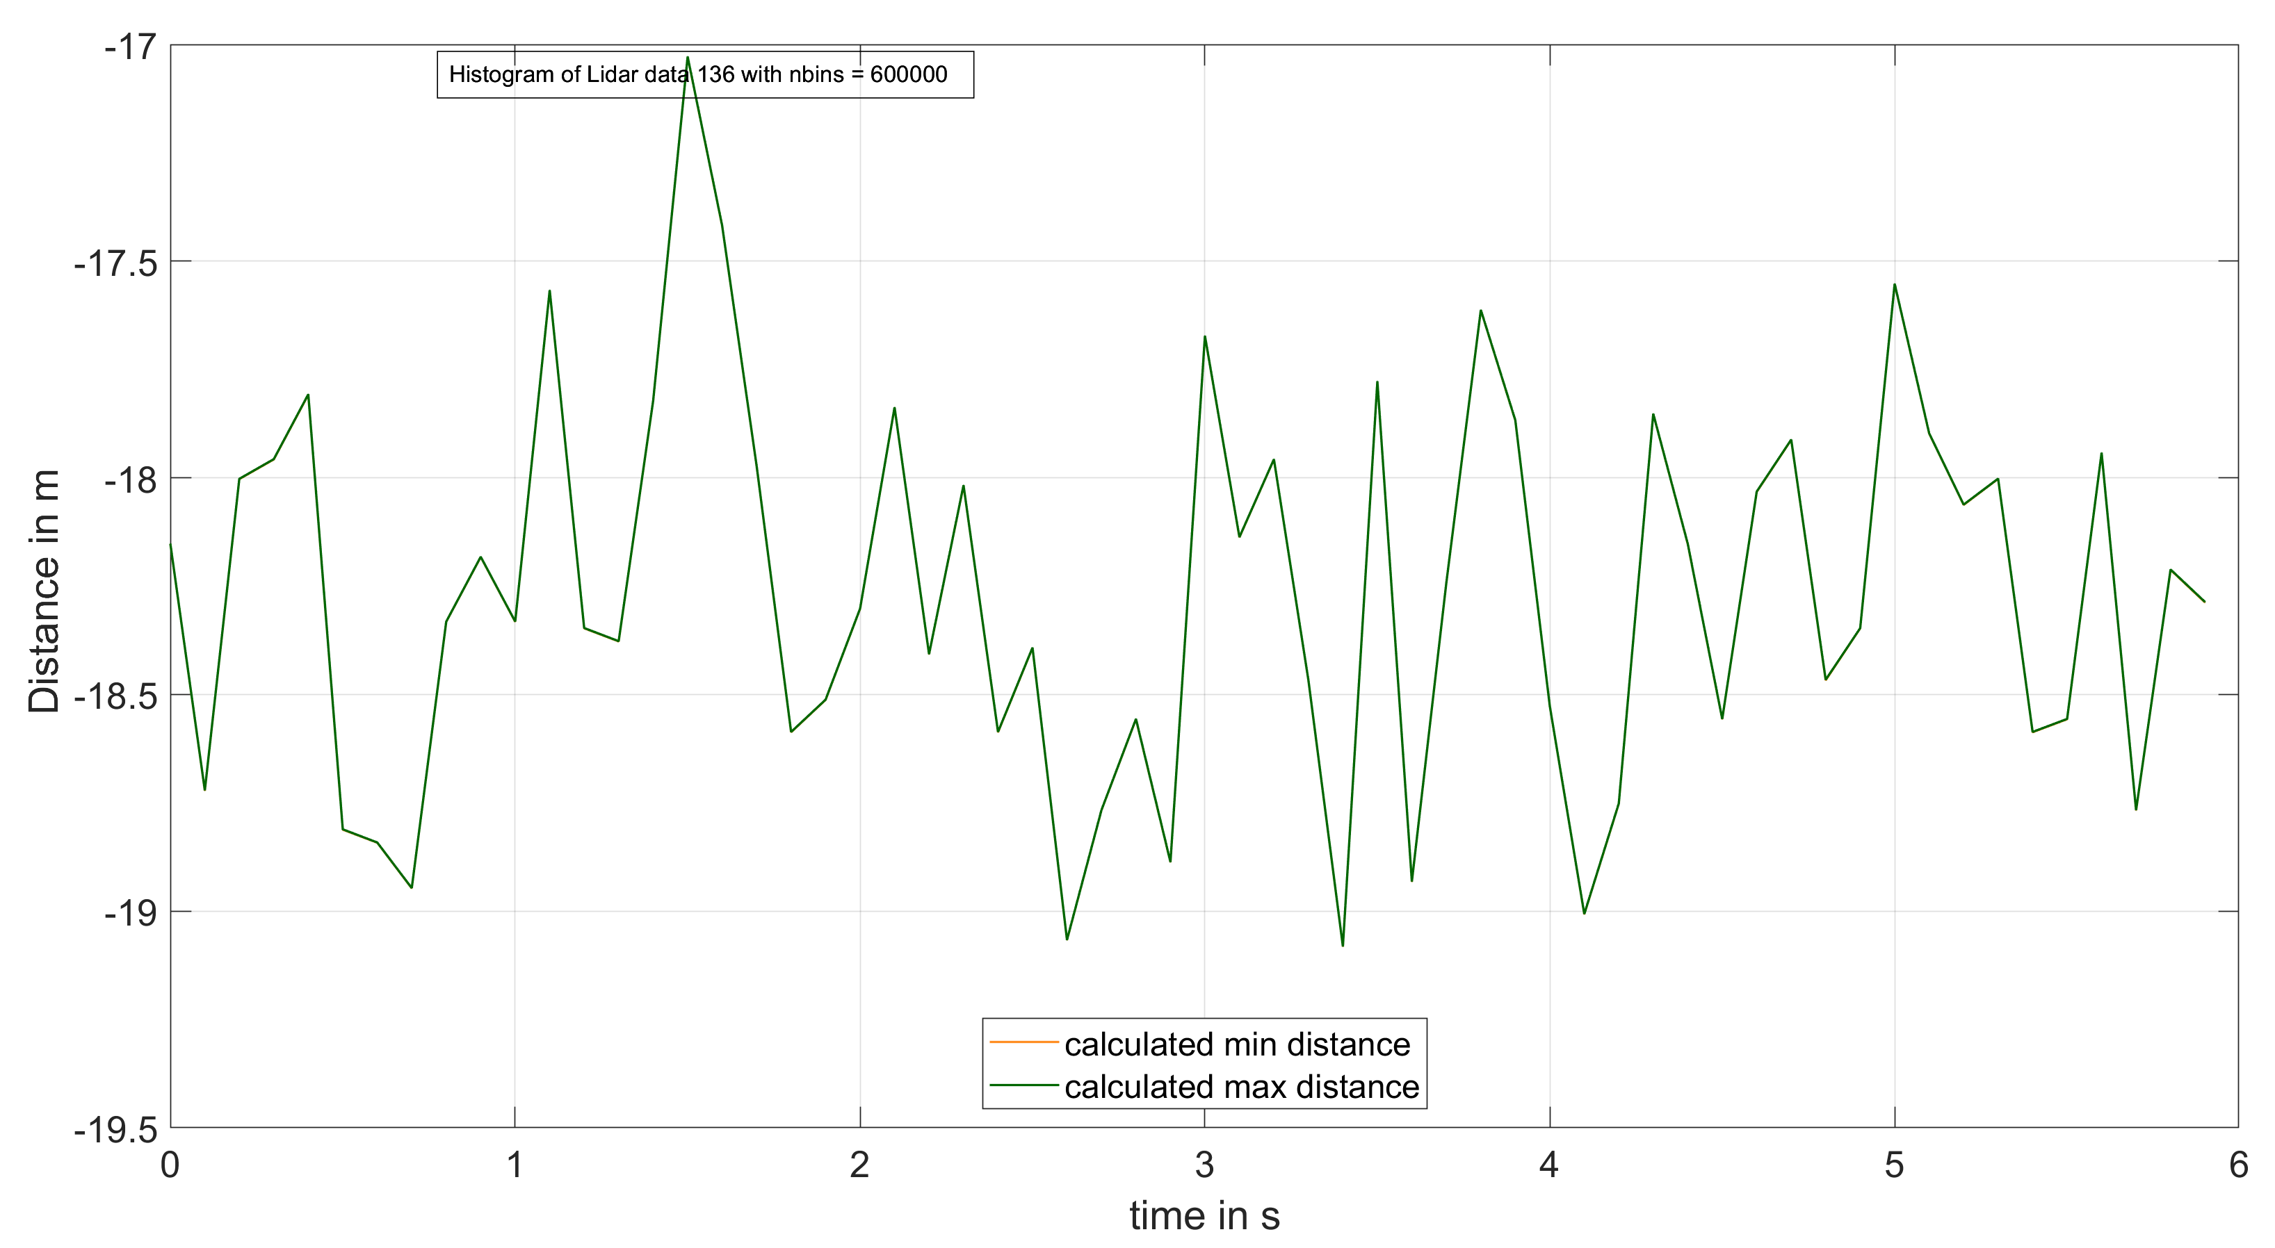

(del_t0)/1000)



**(Shelby basement static).No video**

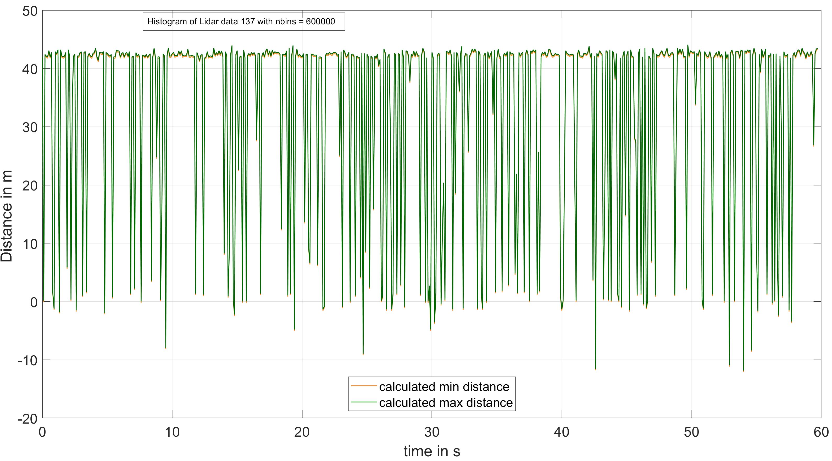

Measured 43.8912 m

(del_t0)/100)

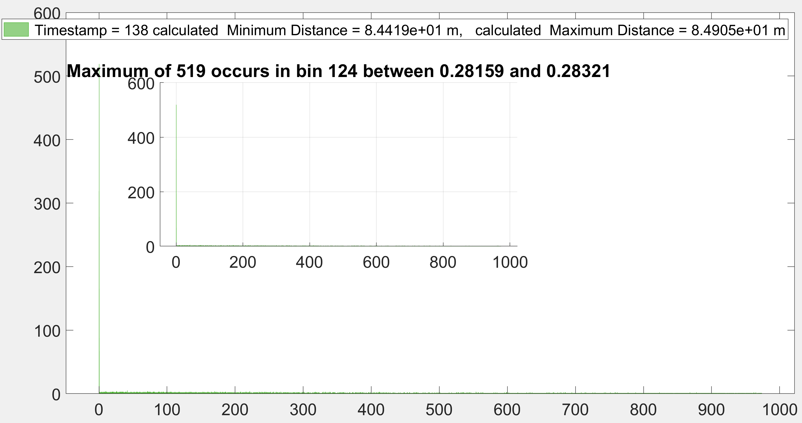

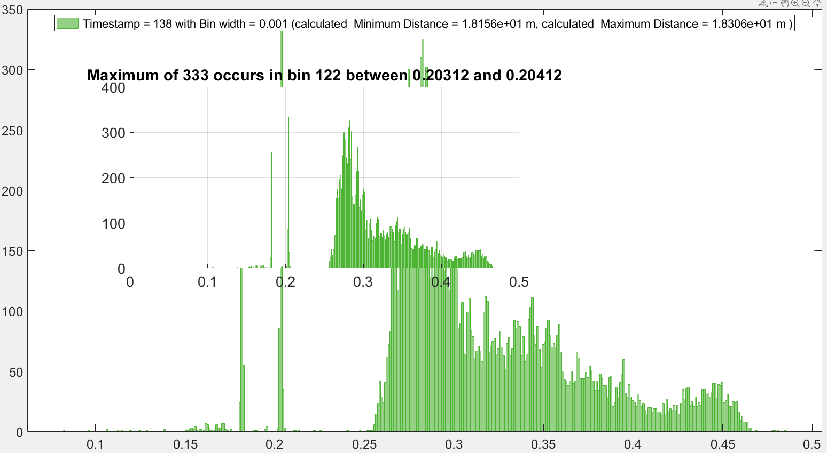

**After zooming**

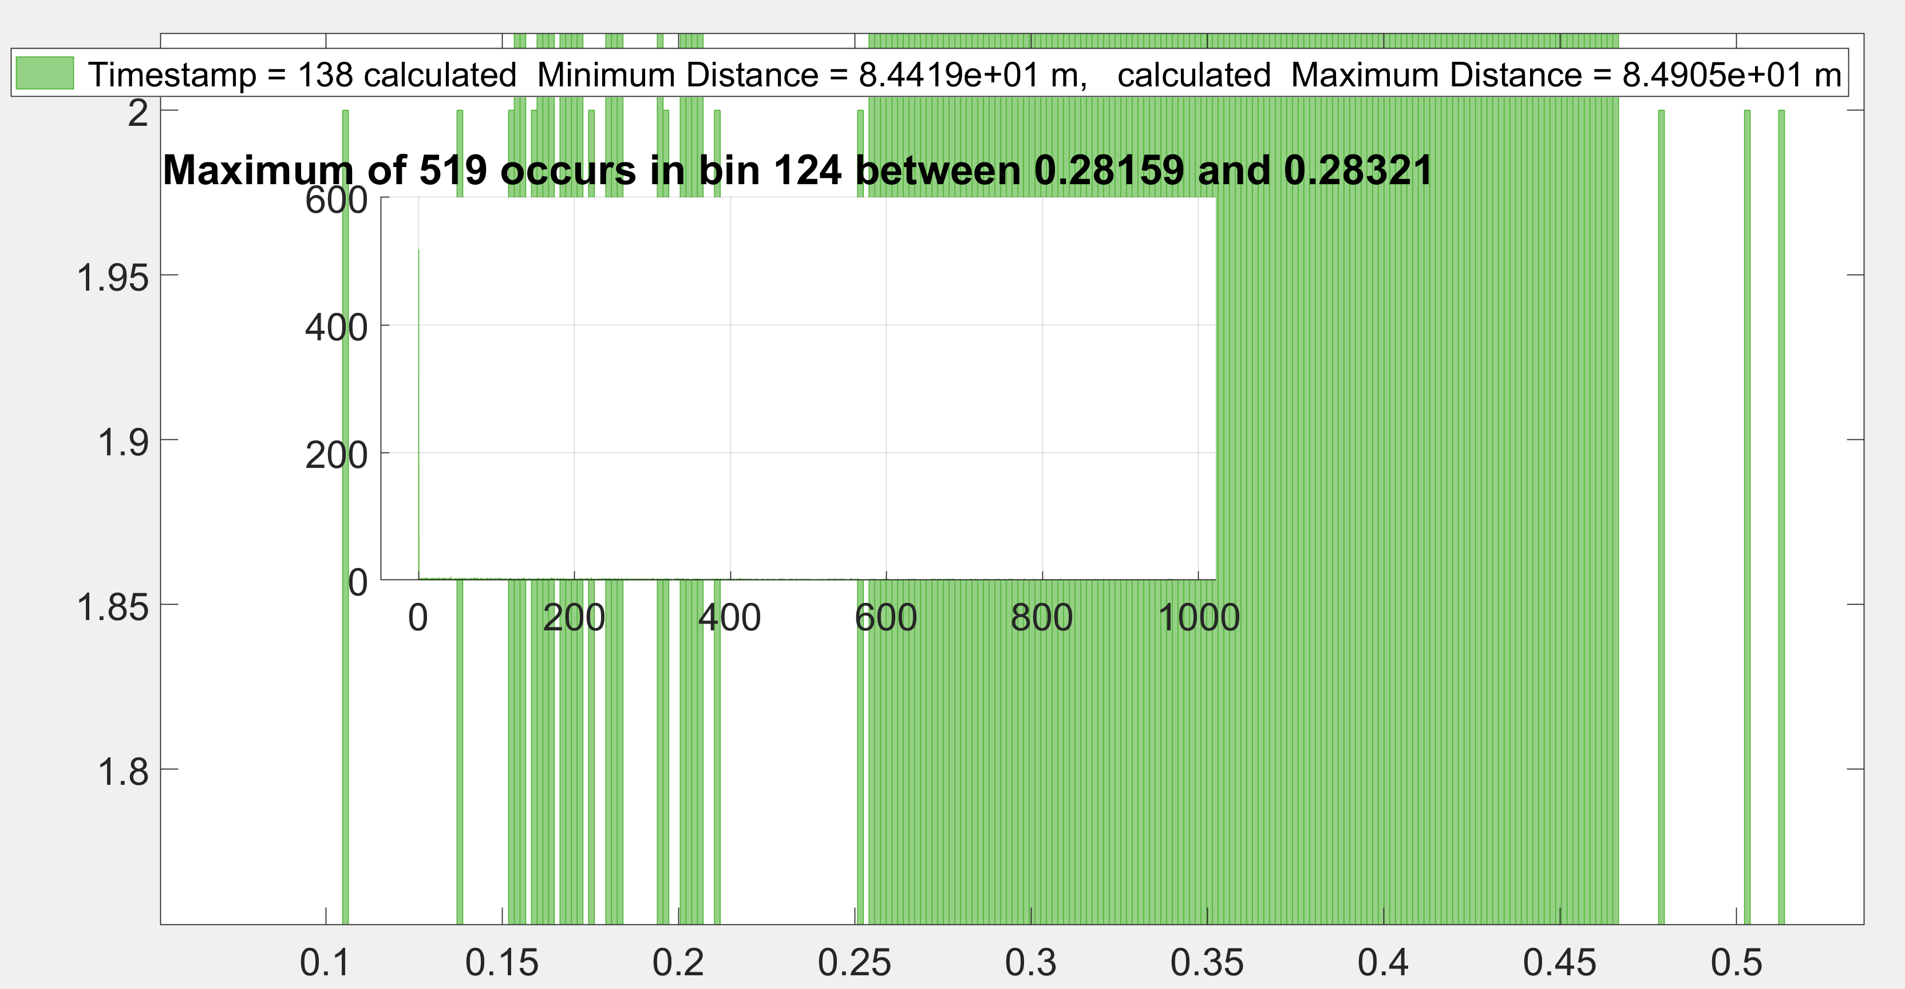

**No video (Shelby basement dynamic). Towards the target**

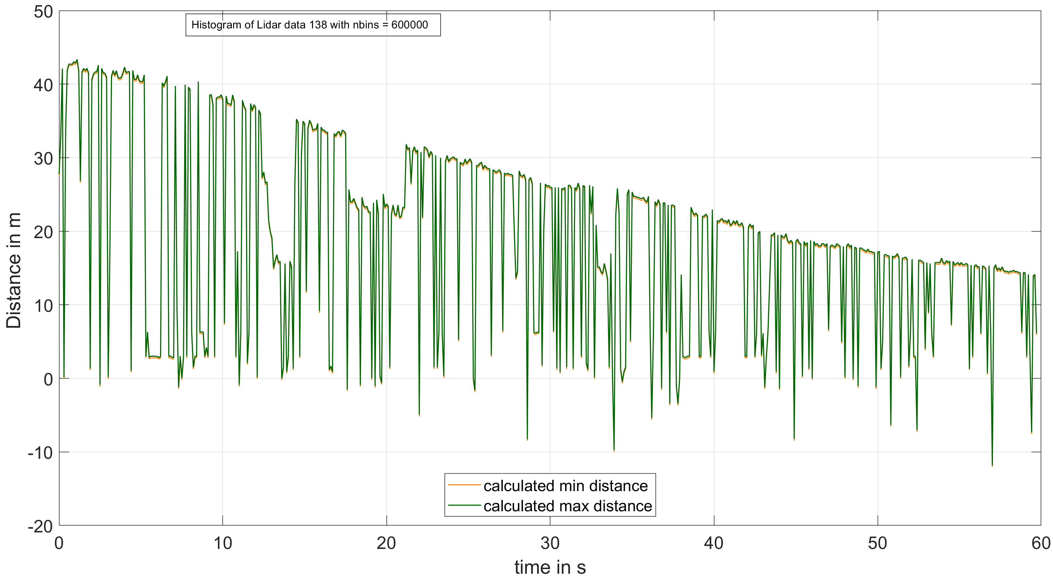

(del_t0)/100)

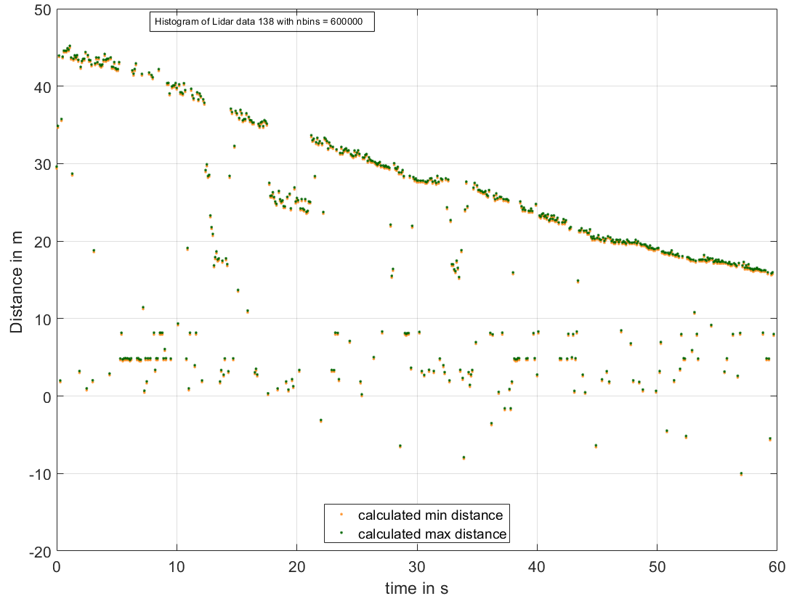

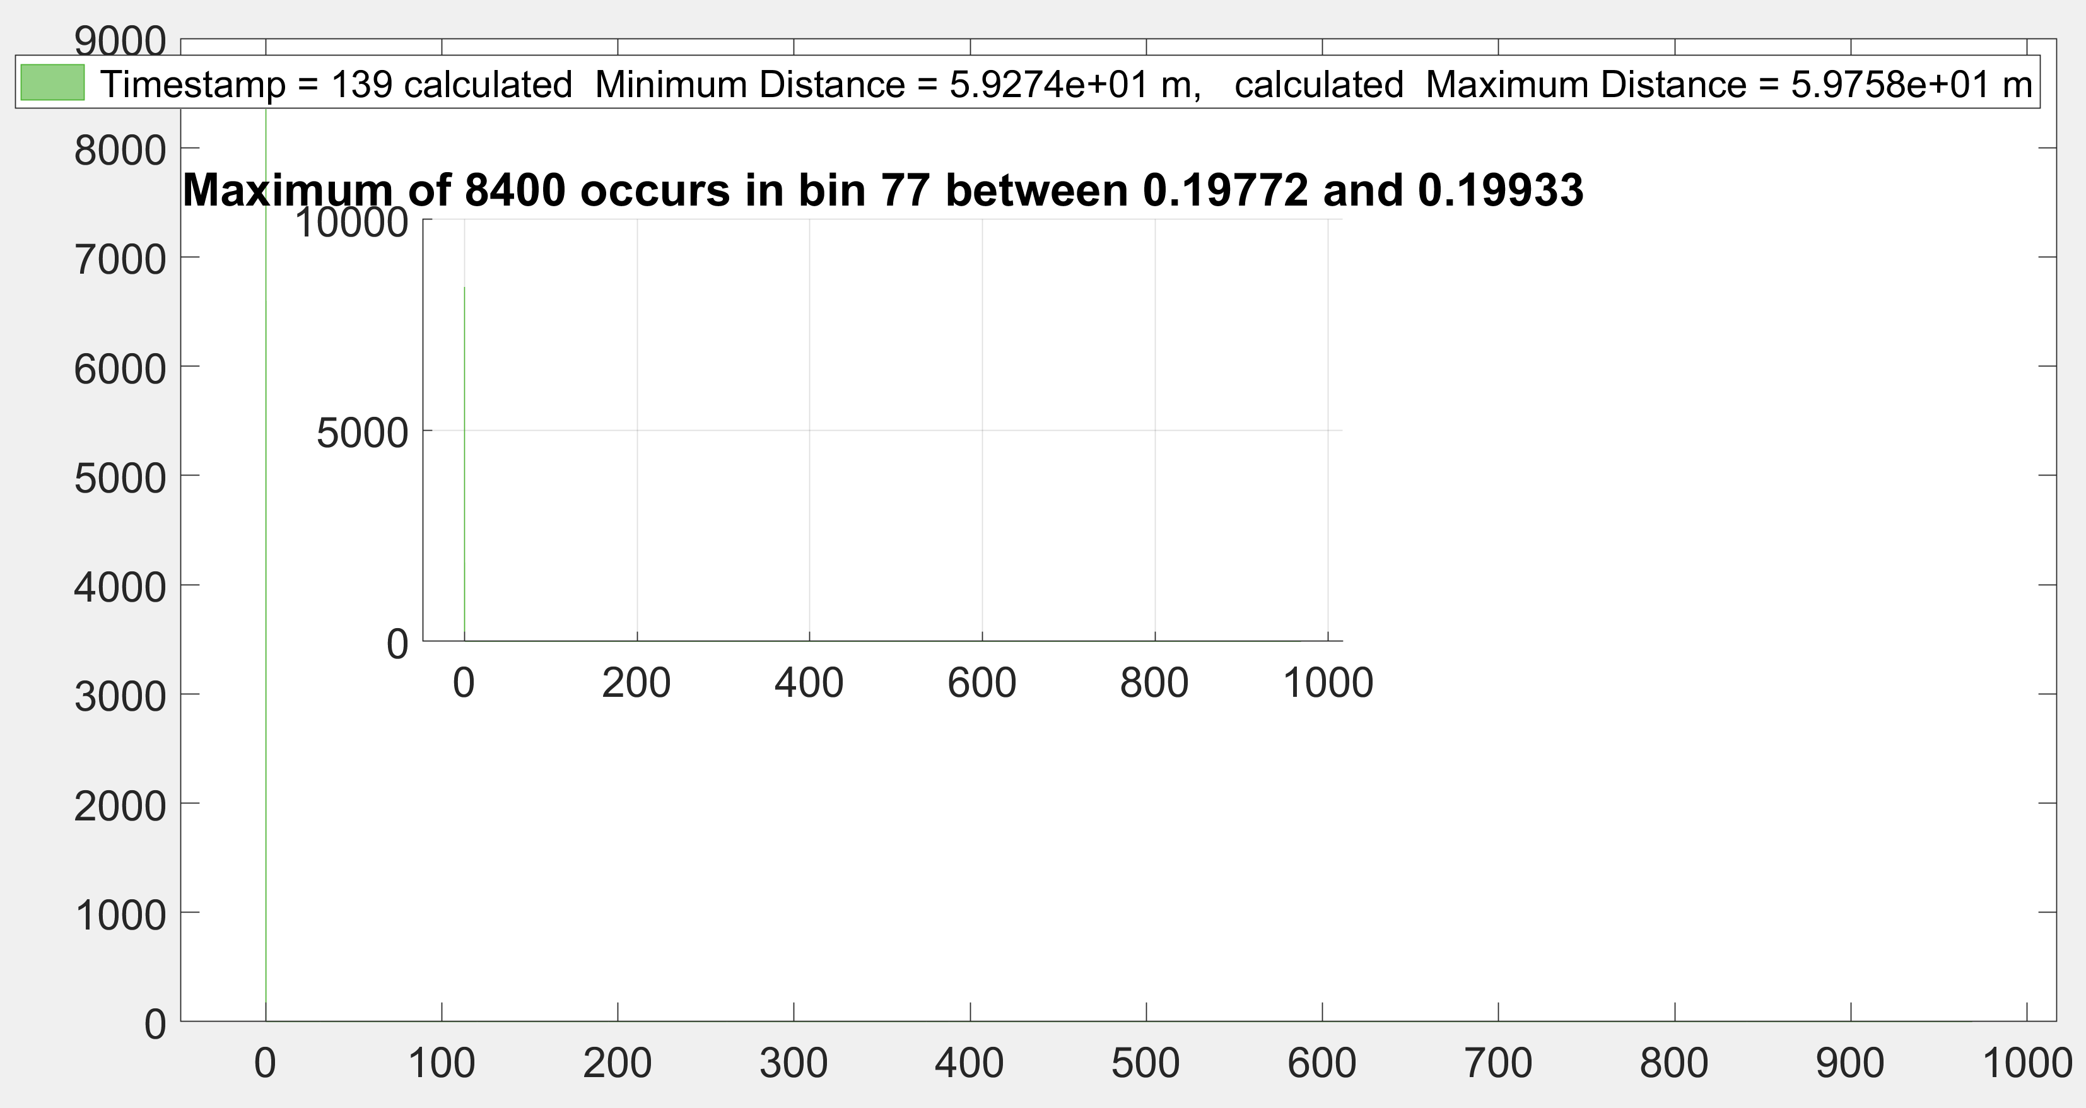

**After zooming**

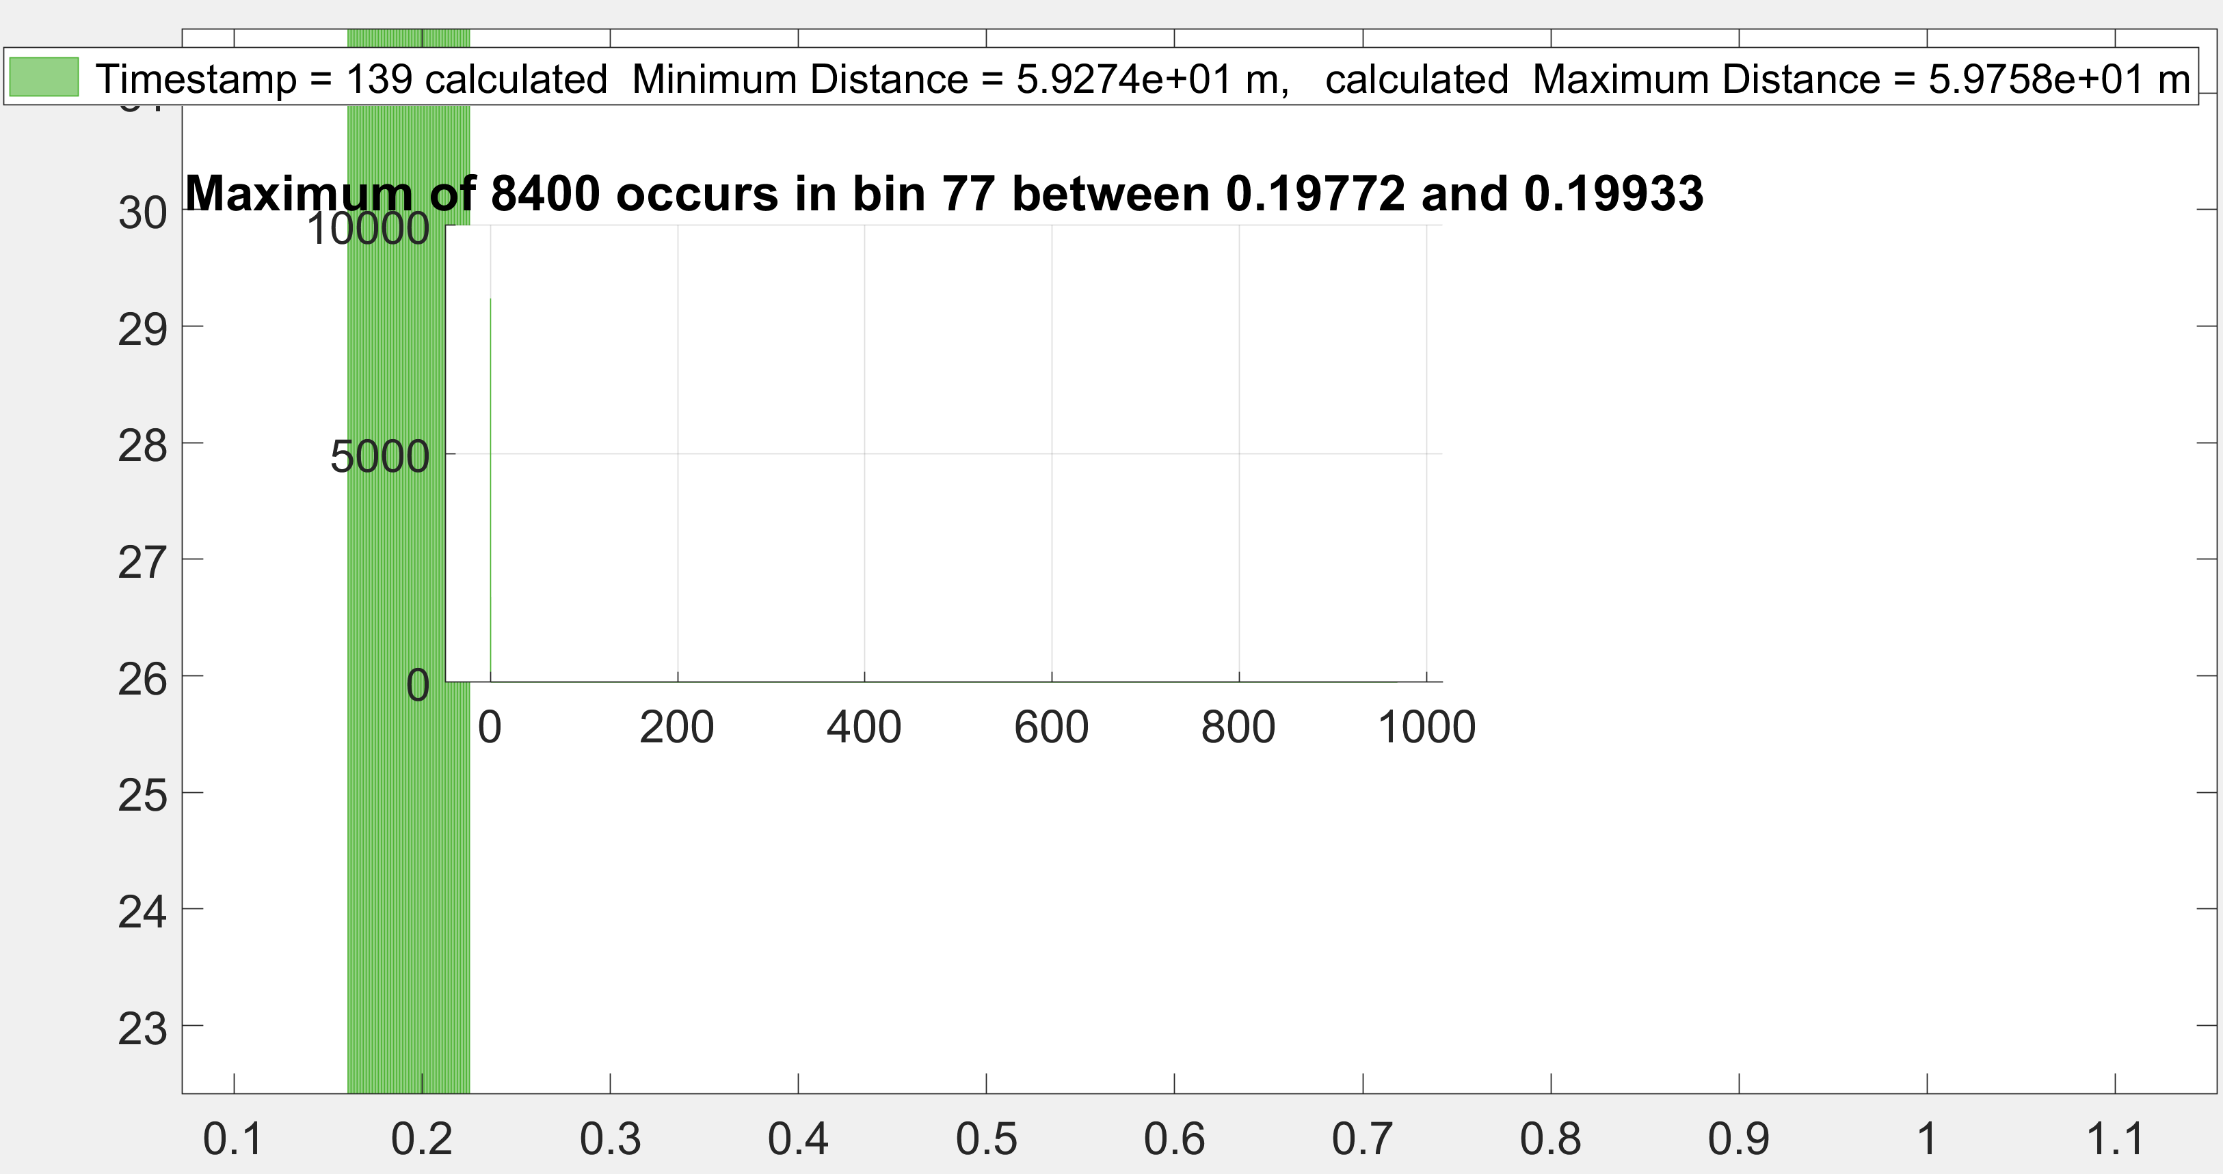

**Please see the video (1st of Shelby basement (dynamic Perpendicular to the target))**

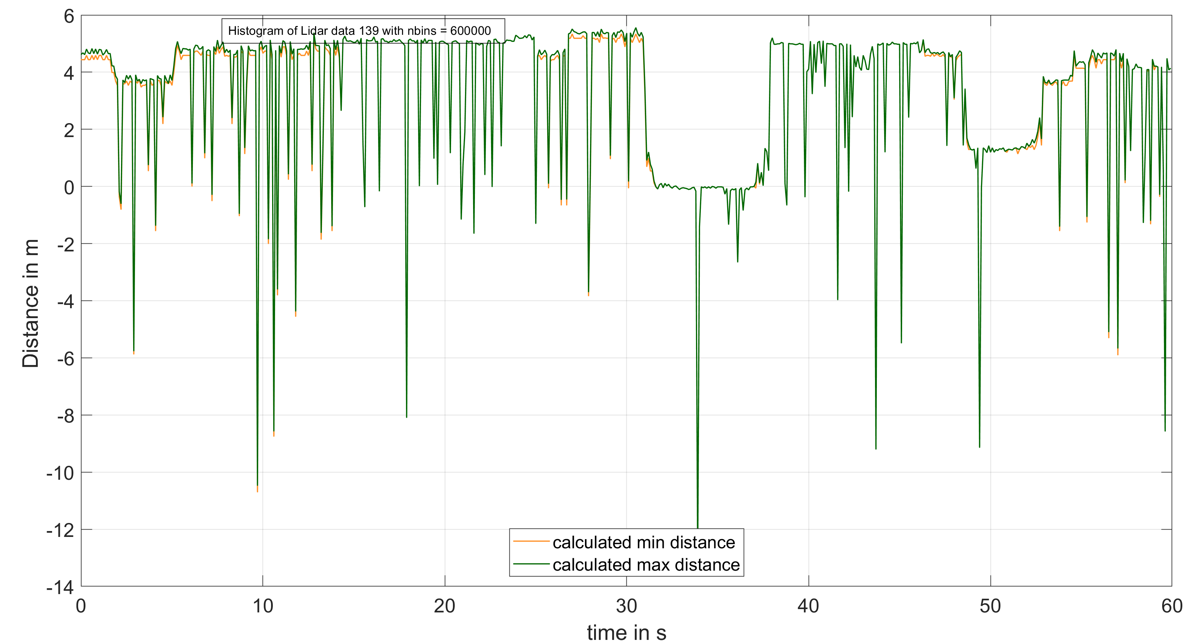

(del_t0)/100)

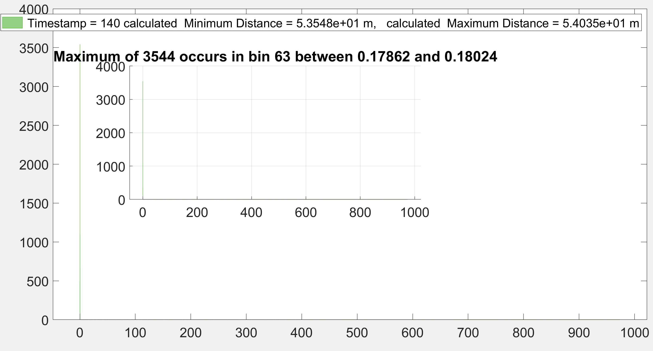

**After zooming**

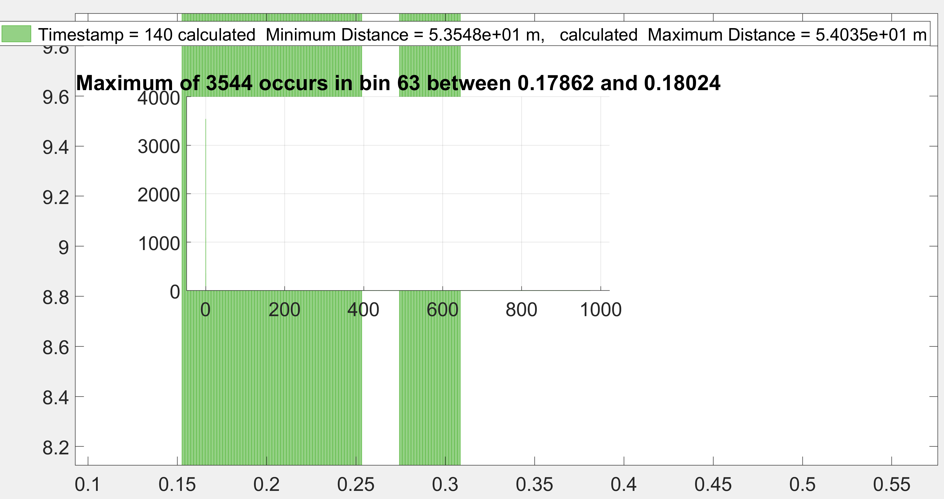

**Please see the video (2nd of Shelby basement dynamic). Perpendicular to the target long side**

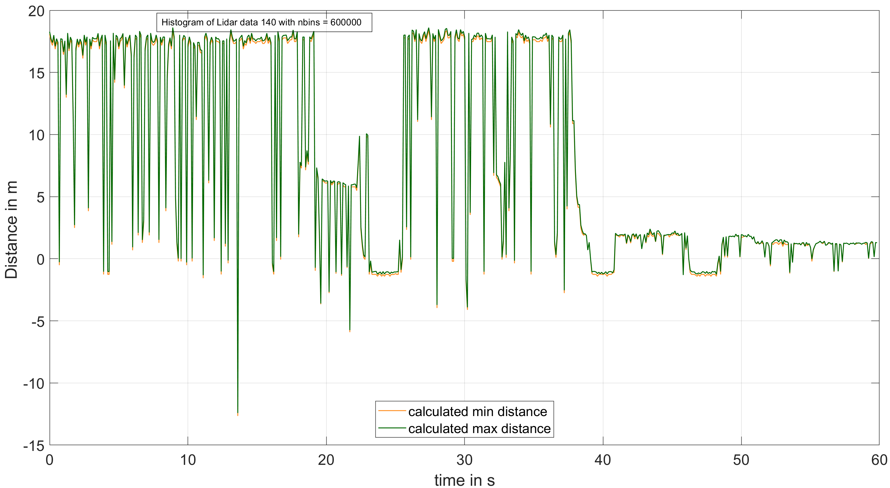

Laser_Start = del_t_min = 0.1624 us;

max probability count from internal reflection

Measured 3.3274 m

Measured 5.842 m

Measured 18.2626 m

(del_t0)/100)

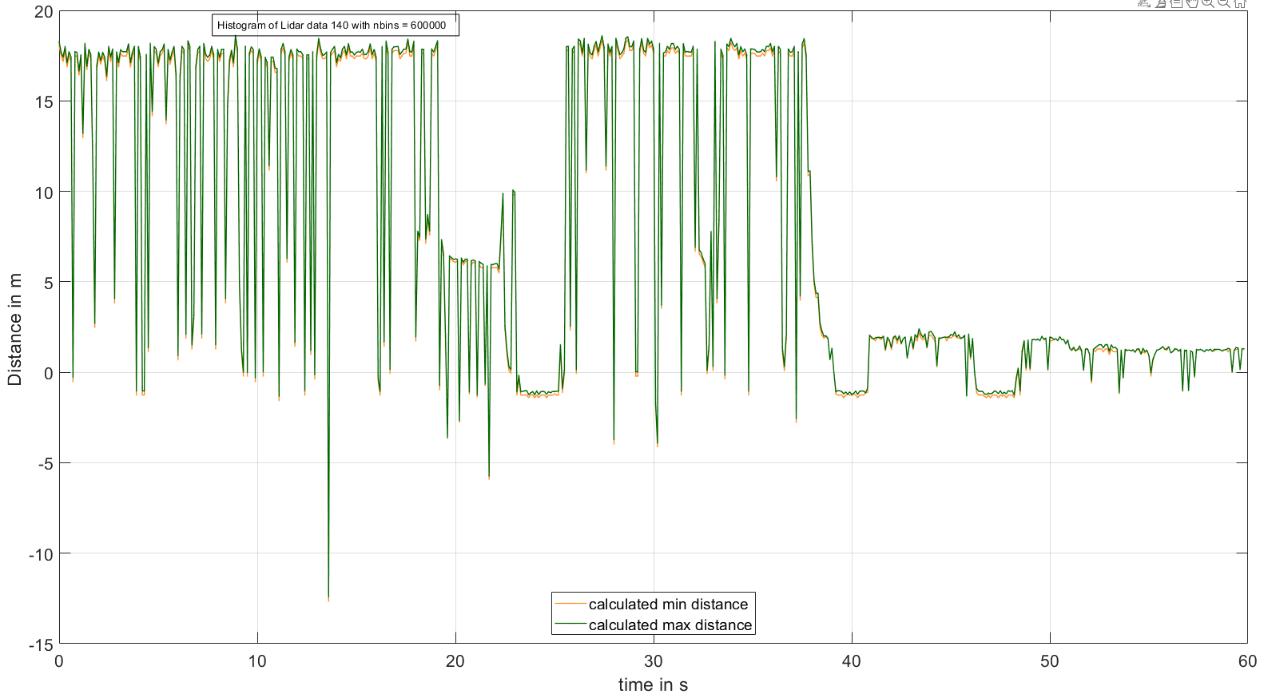

(del_t0)/100)

Laser_Start = ave(del_t_min) = 0.2136 us;

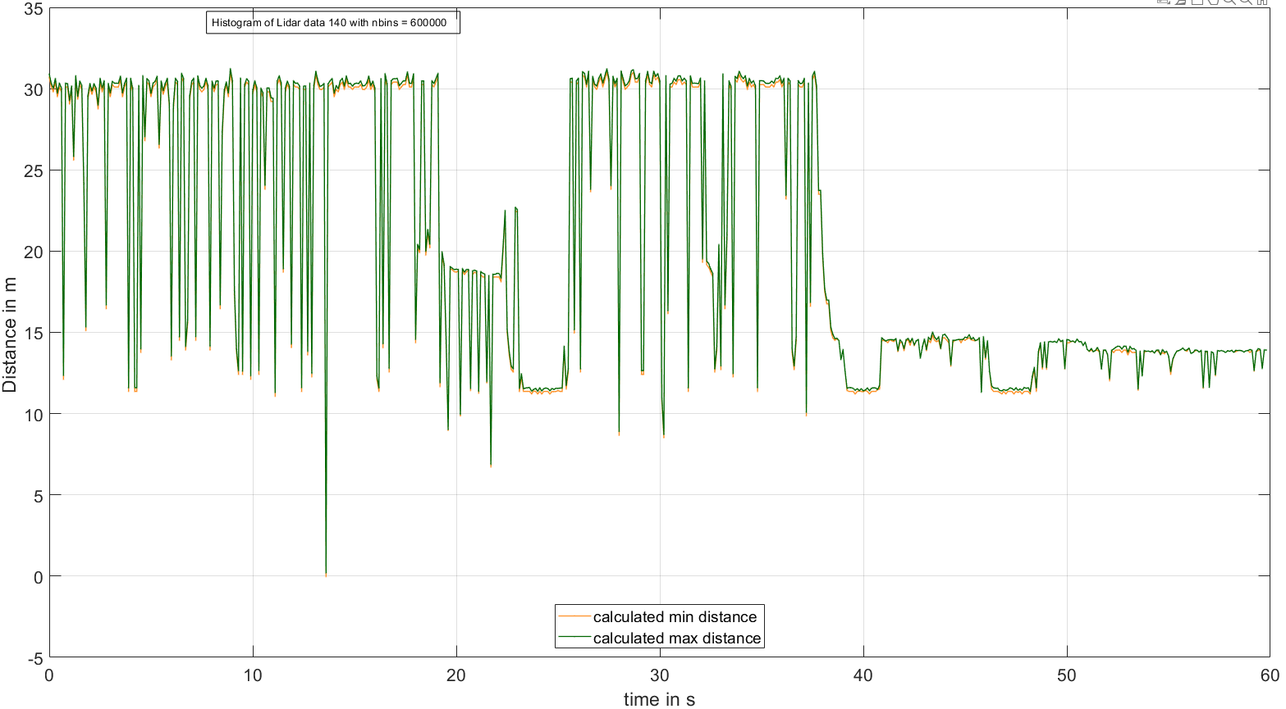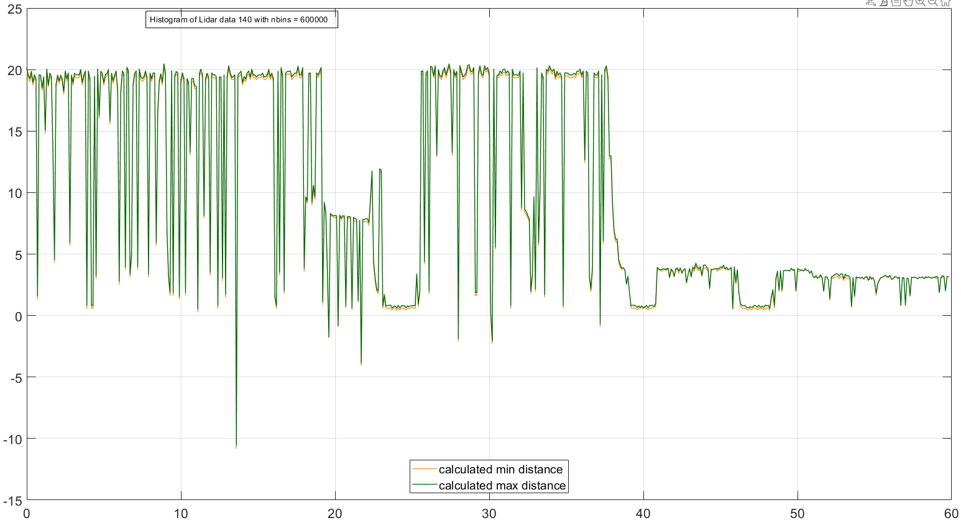

Laser_Start = 0.150 us; (random value)

(del_t0)/100)

(del_t0)/100)

Laser_Start = del_t_min_W = 0.0782 us;

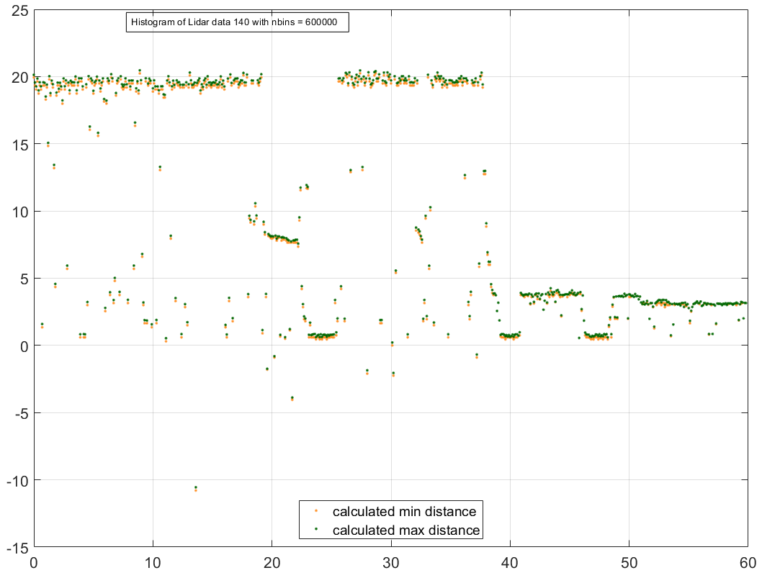

**Summary and comments:**

* **The dynamic code is in beta version that means it only counts one most probable density of out possible histograms, so results are basically 1st order or from one most reflecting target (no matter the distance is). So the next step is to get multiple target.**
* **The NERC basement measurement are promising both static and dynamic.**
* **the main problem of outdoor measurement is not the photon counting rather TDC start timing. On those dynamic graphs I took that it takes about 24 m (0.162 micros of 2 way) to start the TDC, so it shows -ve distance.**

So it seems Indoor we can rely on a stable TDC start time but outdoor we can’t as for the high probability of false TDC stop conditions. The Single-Photon Counting Module (SPCM) has dark count rate (500cps) and a dead time of 22ns after each photon detection.

**Changing nbins:** nbins = round((del_t_max- del_t_min)/bin_width);

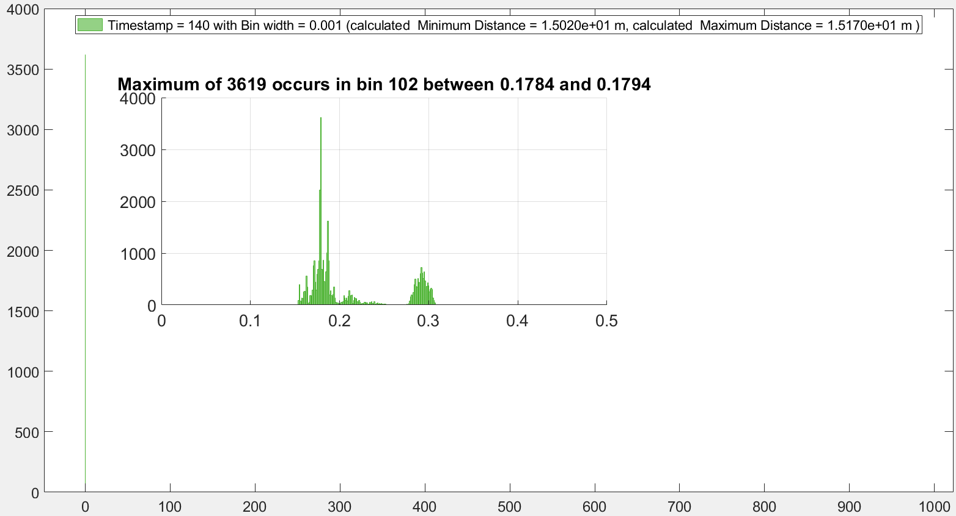

nbins : 973725

bin_width: 1 ns

dynamic run shooting at multiple target at multiple distance

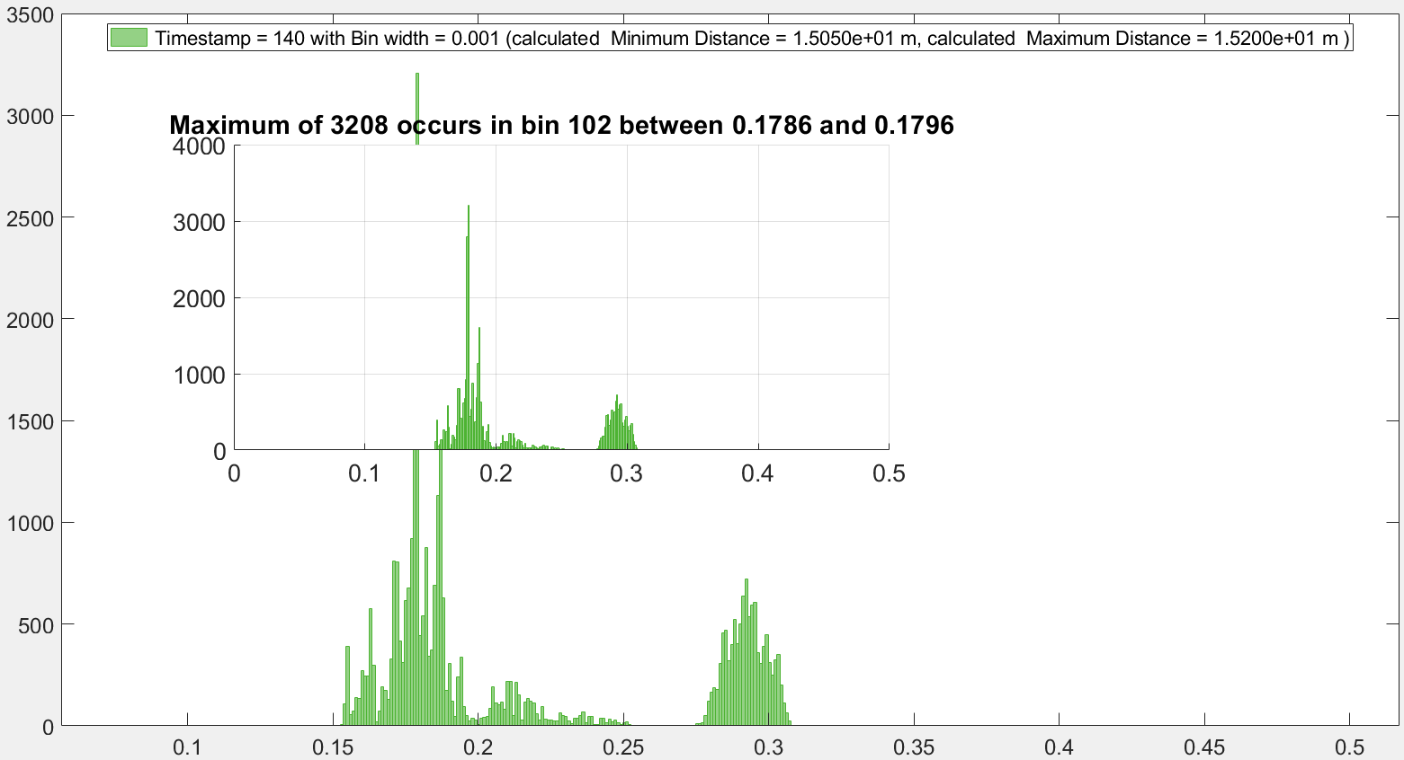

After deleting the rows of del_t >0.3 us

nbins : 418

bin_width: 1 ns

dynamic run shooting at multiple target at multiple distance

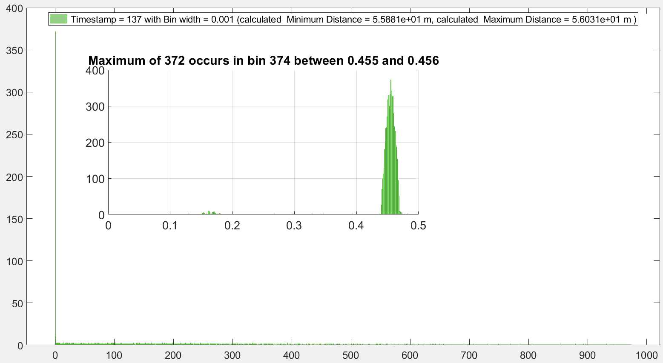

nbins : 973577

bin_width: 1 ns

Static run shooting at one target (the long stationary wall).

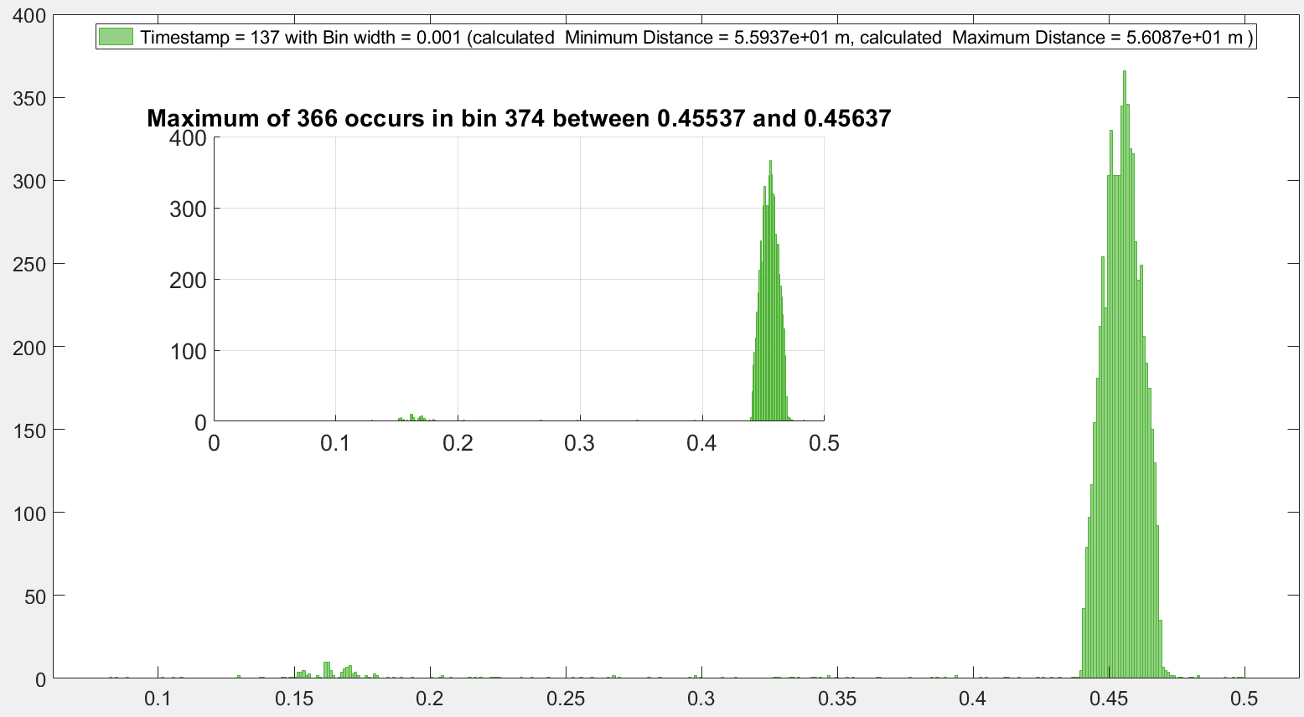

After deleting the rows of del_t >0.5 us

nbins : 417

bin_width: 1 ns

Static run shooting at one target (the long stationary wall).

**Dynamic platform changing to fixed bin width**

bin_width = 0.001; %0.1 ns

nbins(i) = round(((del_t_max(i))-(del_t_min(i)))./bin_width);

Same as:

h(i)= histogram(j,'BinWidth',0.001);

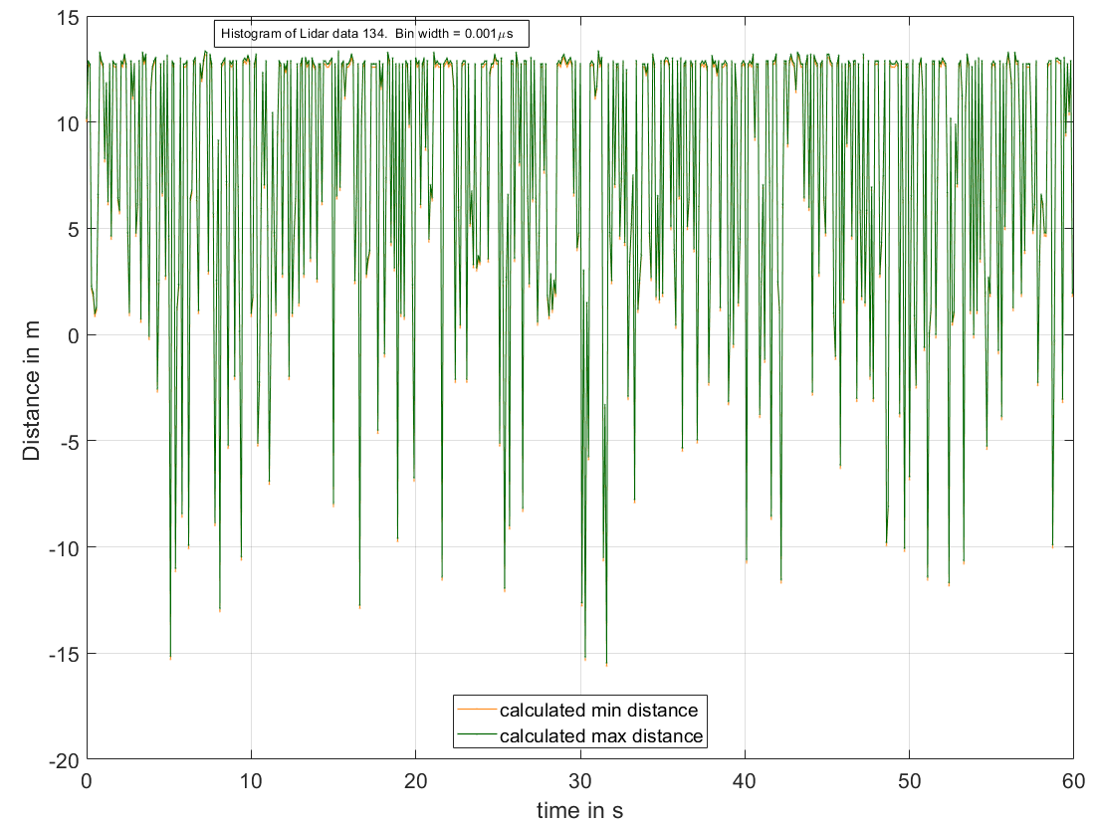

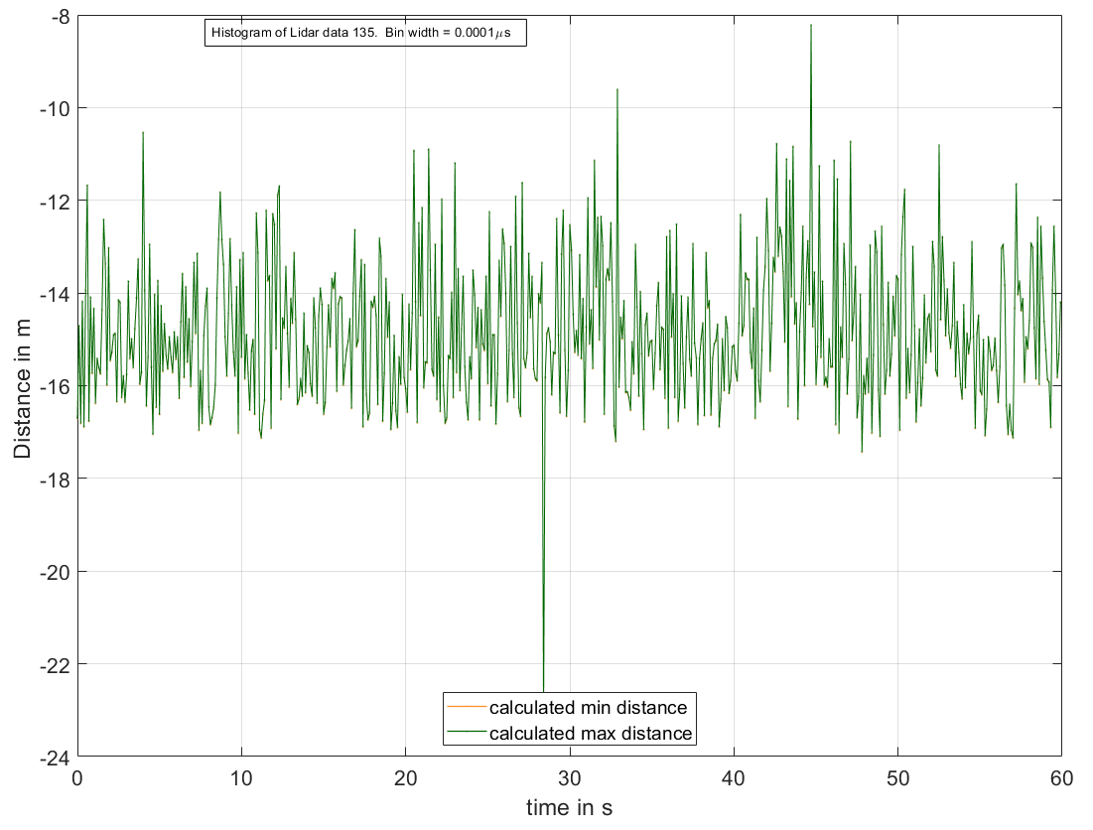

For run 135, For Bin_width 0.001 us it gets 428 bins in a particular row and cannot proceed anymore. But can run for bin_width 0.0001, when nbins=4280

Index exceeds the number of array elements (428).

Error in test_dynamic2_Lidar (line 63)

[maxcount(i), whichbin(i)] = max(h(i).Values(i));

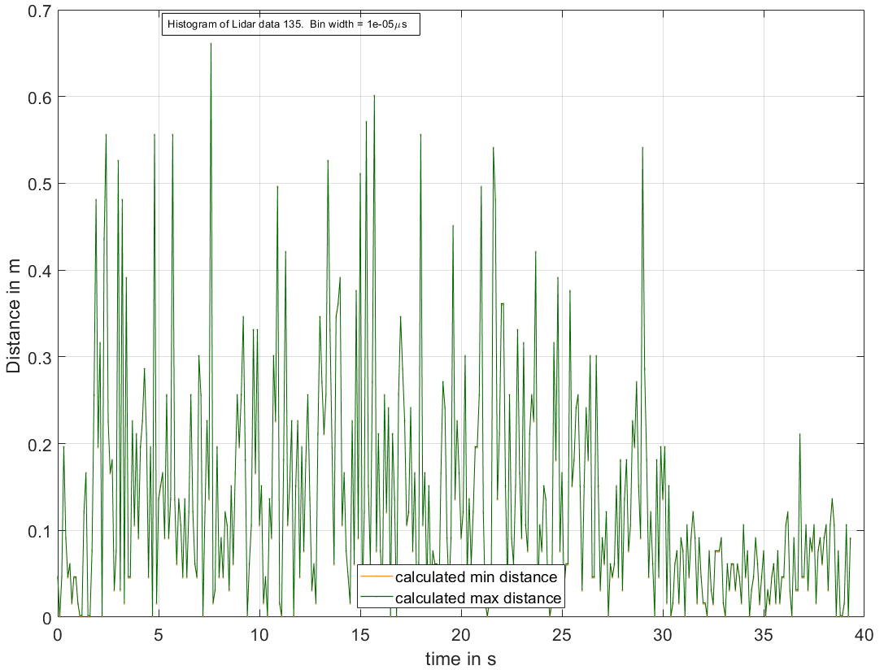

For run 135, if we remove all the TOF values before laser starts:

rowsToDelete_low = (Timestamp_ < 0.14999)

Then for Bin_width 0.0001 us it gets 99 bins in a particular row and cannot proceed anymore. But can run for bin_width 0.00001

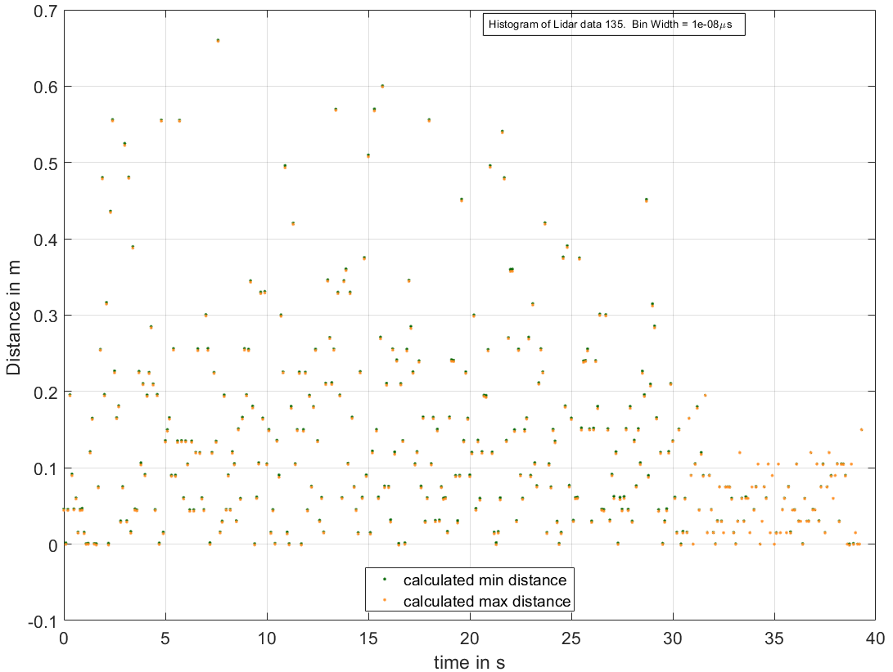

rowsToDelete_high = (Timestamp_ > 1.5); % get rid of higher TOF values

rowsToDelete_low = (Timestamp_ < 0.15); % get rid of higher TOF values

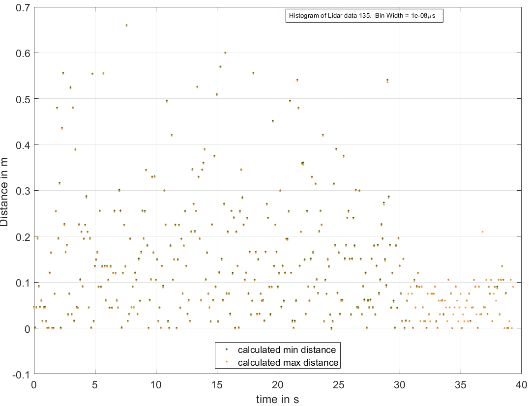

rowsToDelete_high = (Timestamp_ > 2.5); % get rid of higher TOF values

rowsToDelete_low = (Timestamp_ < 0.15); % get rid of higher TOF values

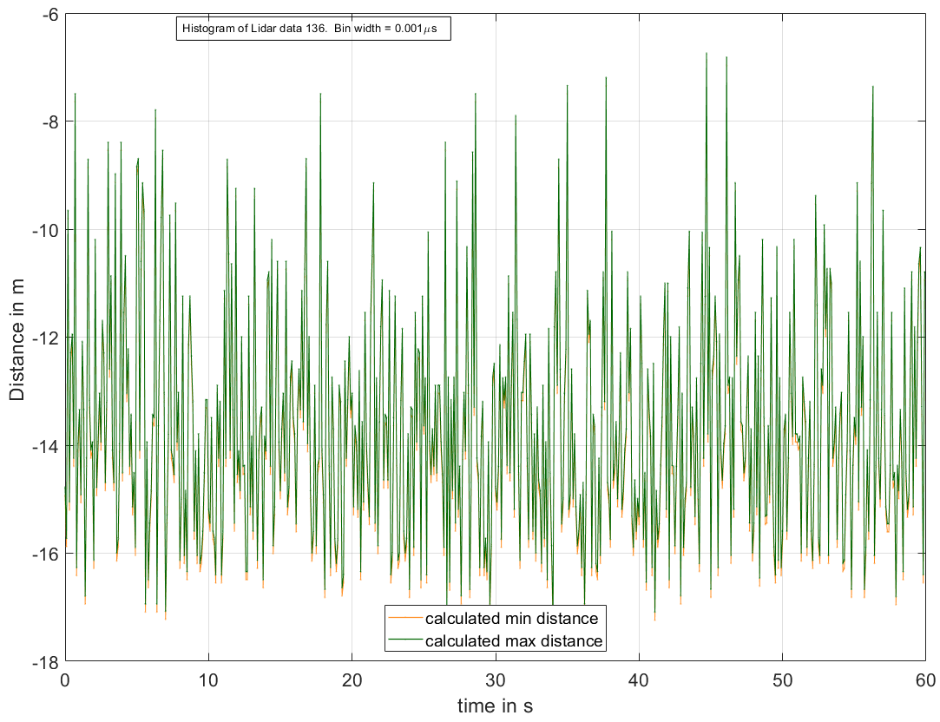

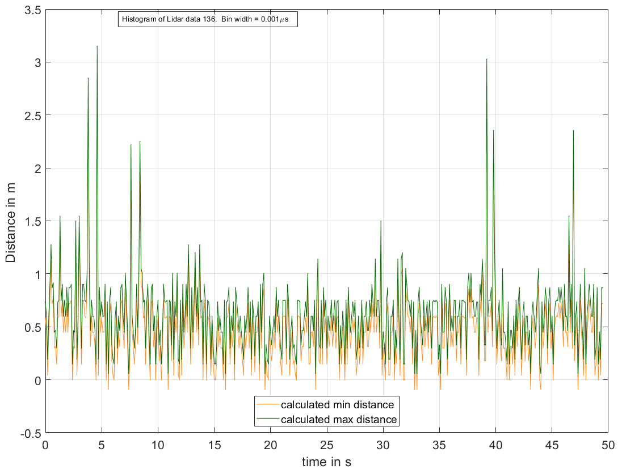

For run 136, if we remove all the TOF values before laser starts:

rowsToDelete_low = (Timestamp_ < 0.14999)

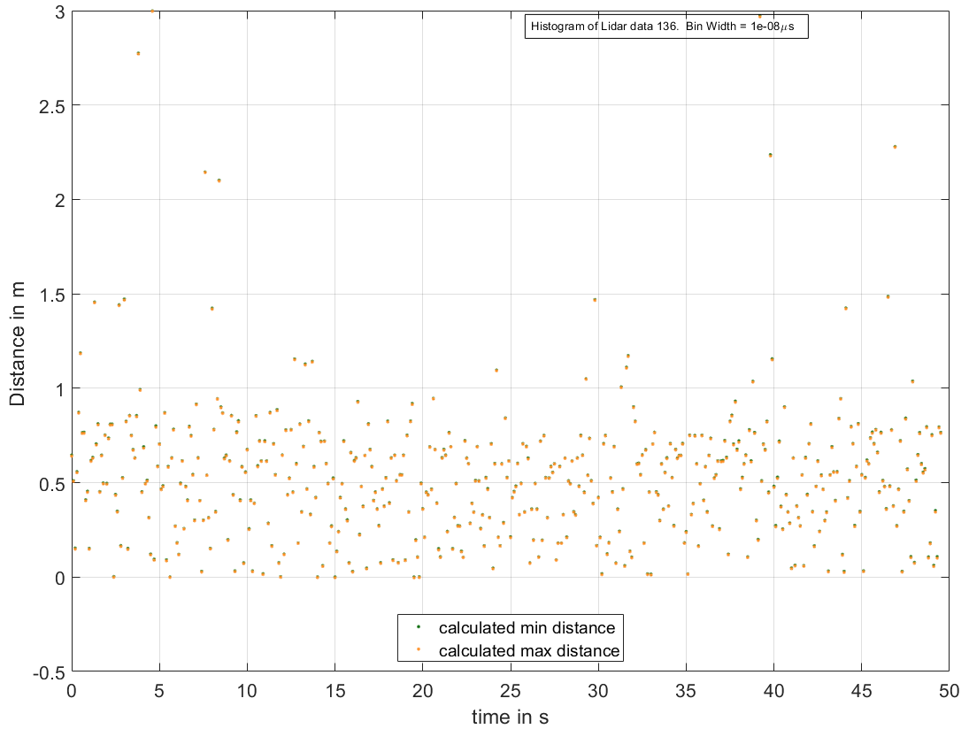

rowsToDelete_high = (Timestamp_ > 3.5); % get rid of higher TOF values

rowsToDelete_low = (Timestamp_ < 0.15); % get rid of higher TOF values

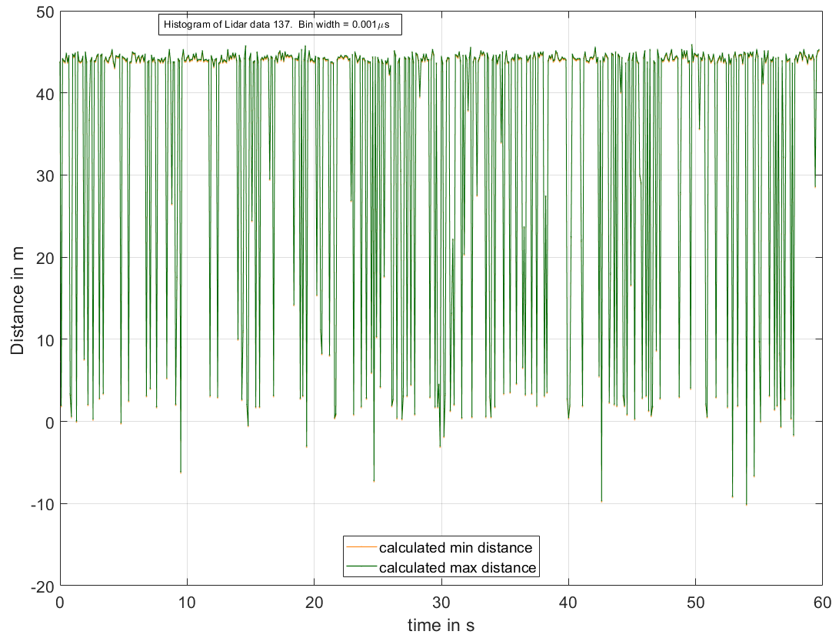

For run 137, if we remove all the TOF values before laser starts:

rowsToDelete_low = (Timestamp_ < 0.14999)

Then one row of nbins comes NAN

Code does not proceed. This situation will cause the problem of number of data length even if we remove NAN.

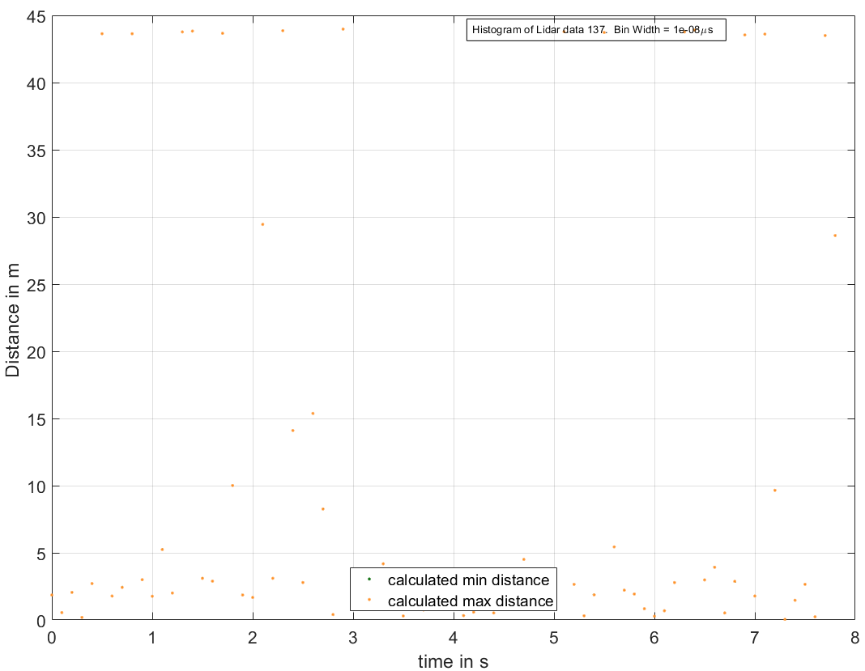

rowsToDelete_low = (Timestamp_ > 0.150); % get rid of higher TOF values

rowsToDelete_high = (Timestamp_ > 0.7); % get rid of higher TOF values

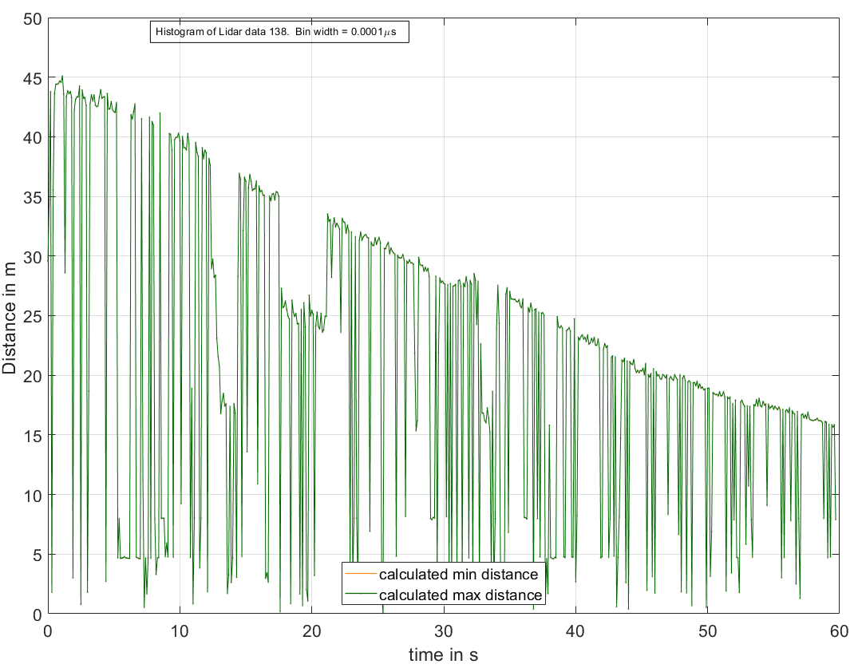

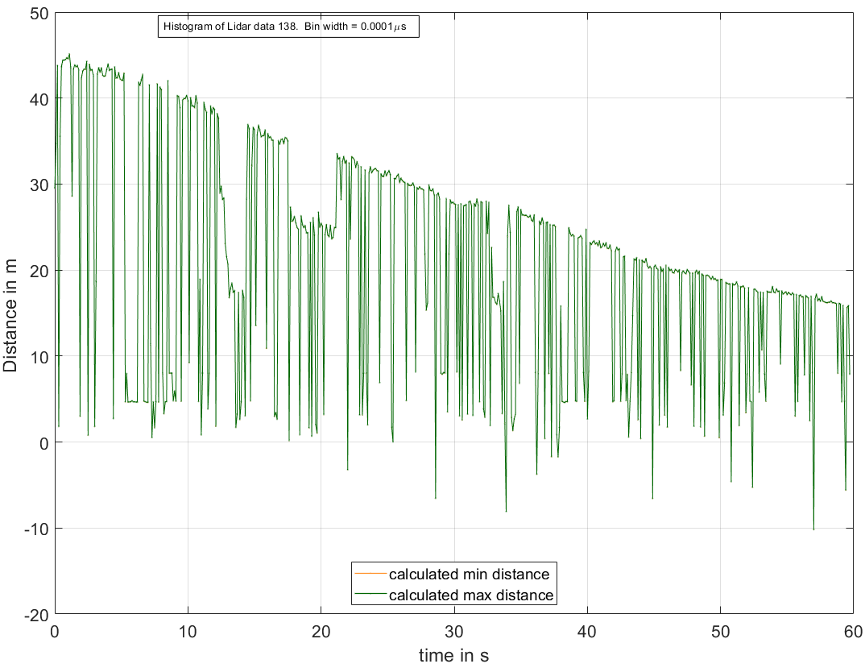

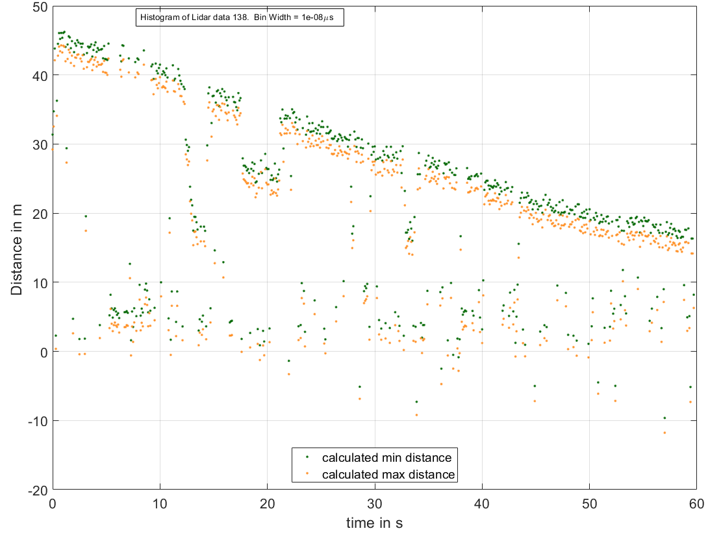

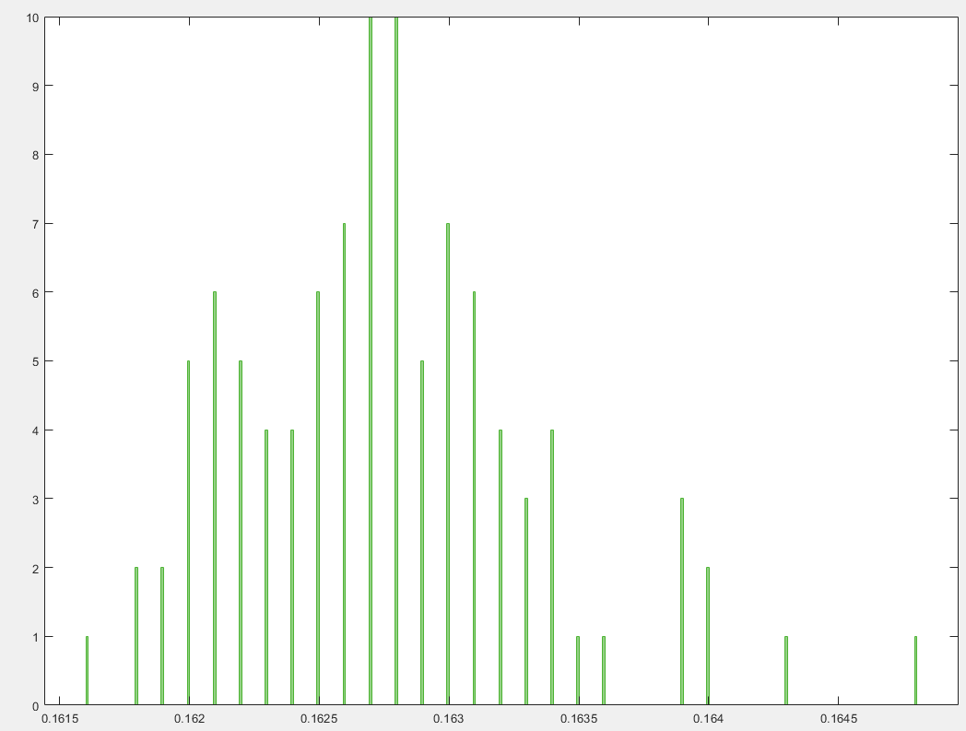

For Run 139, even for Bin_width 0.00001 us it gets 320 bin in a particular row and cannot proceed anymore

Index exceeds the number of array elements (320).

Error in test_dynamic2_Lidar (line 63)

[maxcount(i), whichbin(i)] = max(h(i).Values(i));

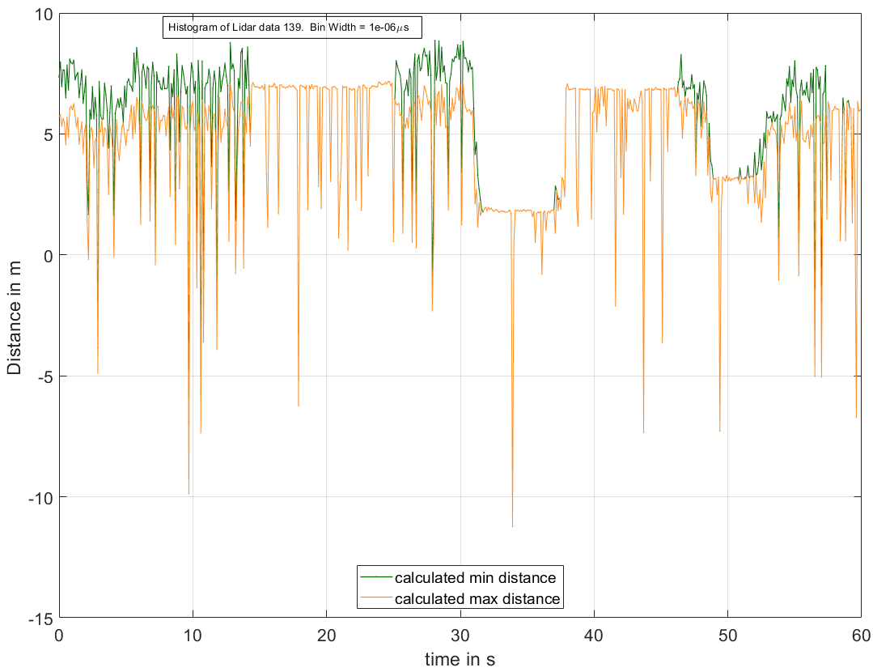

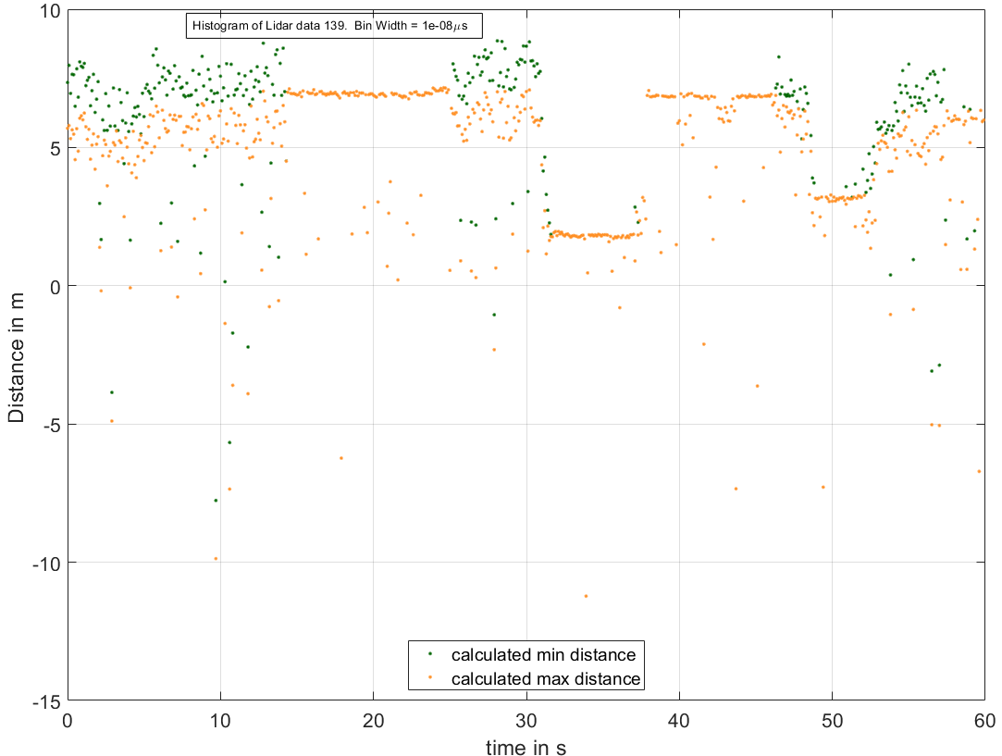

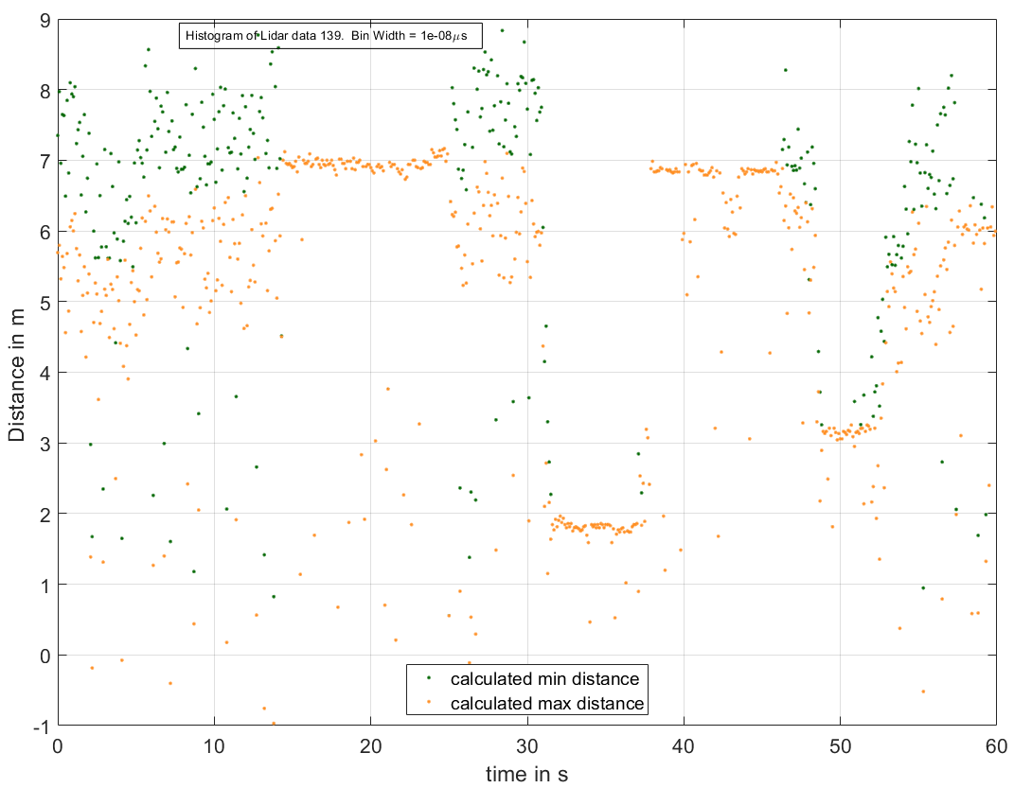

rowsToDelete_low = (Timestamp_ < 0.150); % get rid of lower TOF values

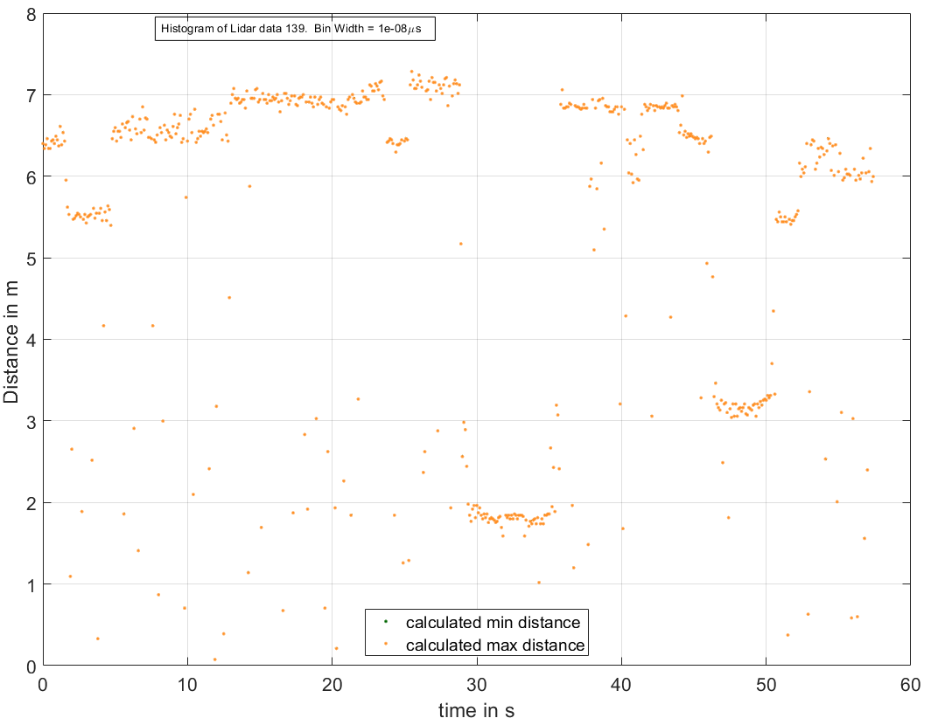

rowsToDelete_high = (Timestamp_ > 0.6); % get rid of higher TOF values

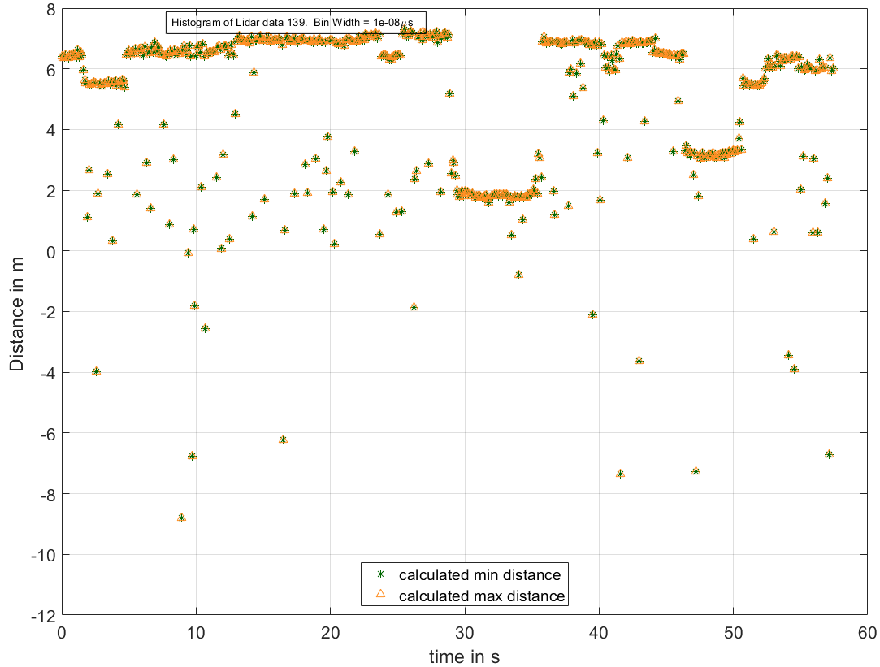

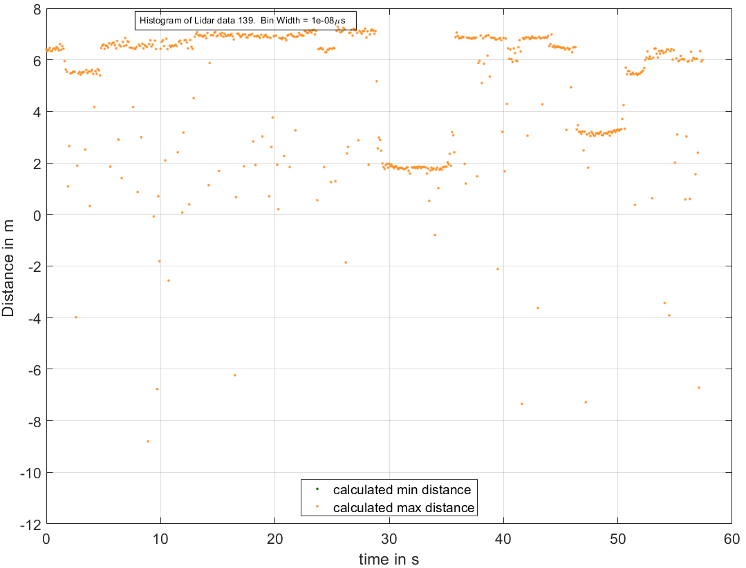

Min and max values actually falls over each other

rowsToDelete_high = (Timestamp_ > 0.6); % get rid of higher TOF values

rowsToDelete_low = (Timestamp_ < 0.150); % get rid of lower TOF values

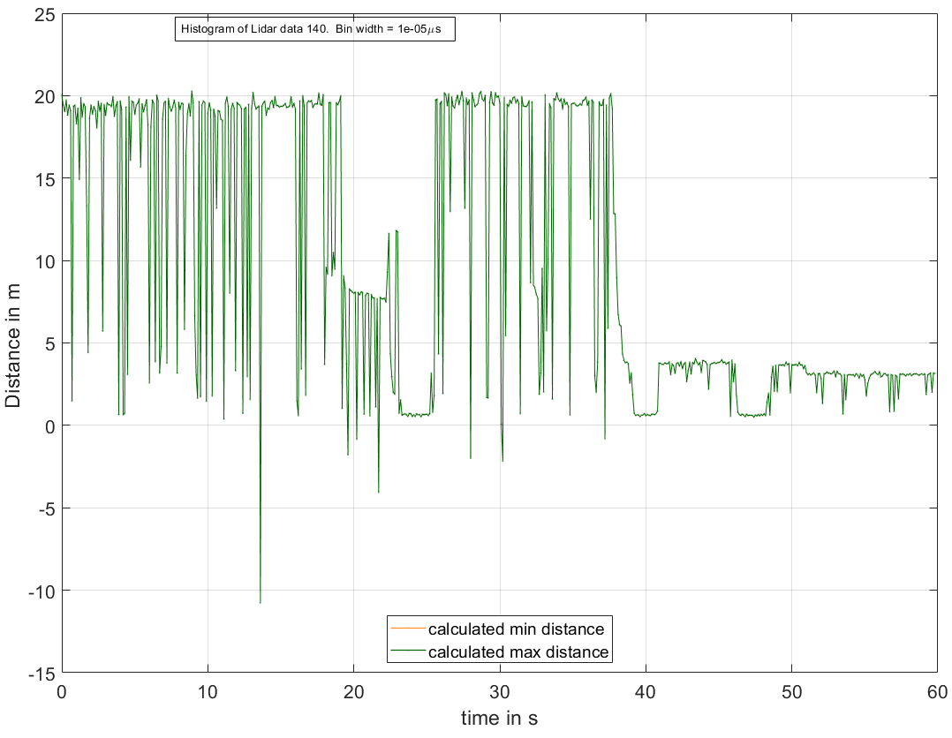

For more information:

<https://www.mathworks.com/help/matlab/ref/matlab.graphics.chart.primitive.histogram-properties.html>

<https://www.mathworks.com/help/matlab/ref/matlab.graphics.chart.primitive.histogram.html;jsessionid=9e4da6005f1d00346e846df2c97d>

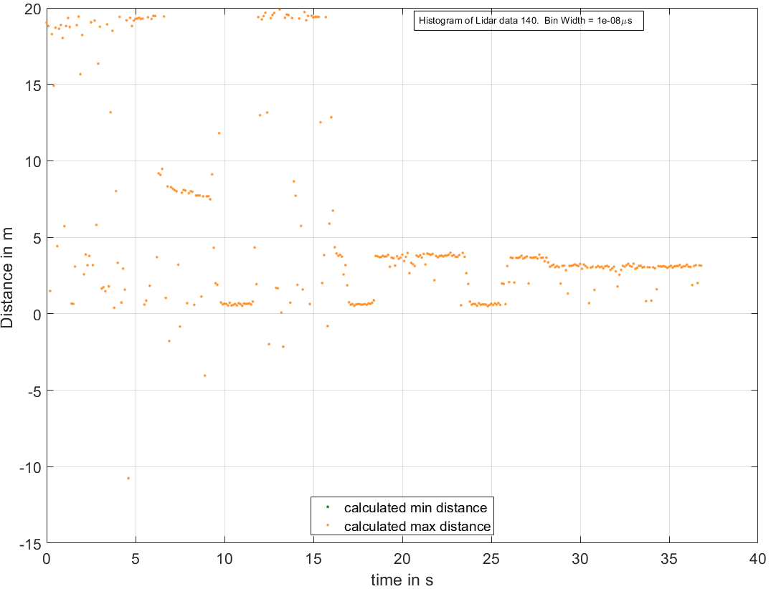

If Timestamp_ < 1.0

Then the run doesn’t progress as min_det_t and max_del_t value in some row become same. 1.0 is the lower TOF max.

rowsToDelete_low = (Timestamp_ > 1.0); % get rid of lower TOF values

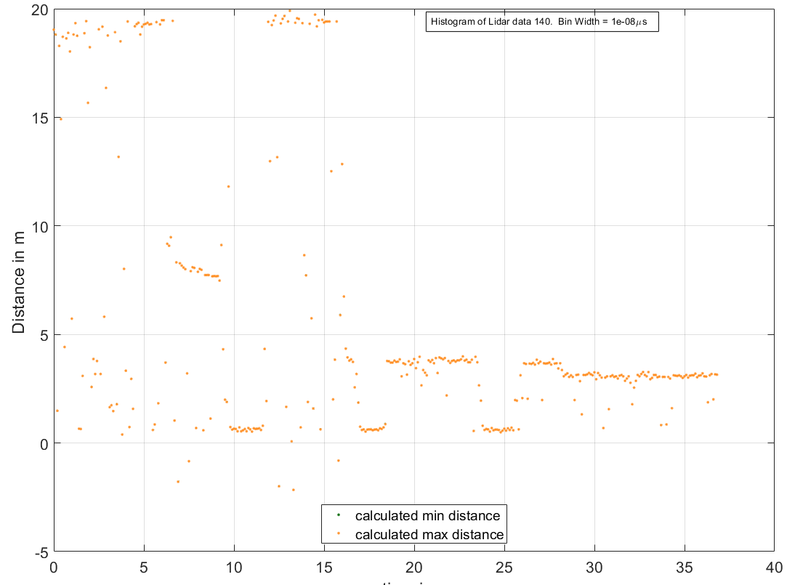

& Timestamp_ < 0.130

Then the run doesn’t progress as min_det_t and max_del_t value in some row become same.

0.130 is the higher TOF min

rowsToDelete_low = (Timestamp_ < 0.130); % get rid of lower TOF values

rowsToDelete_high = (Timestamp_ > 1.0); % get rid of higher TOF values

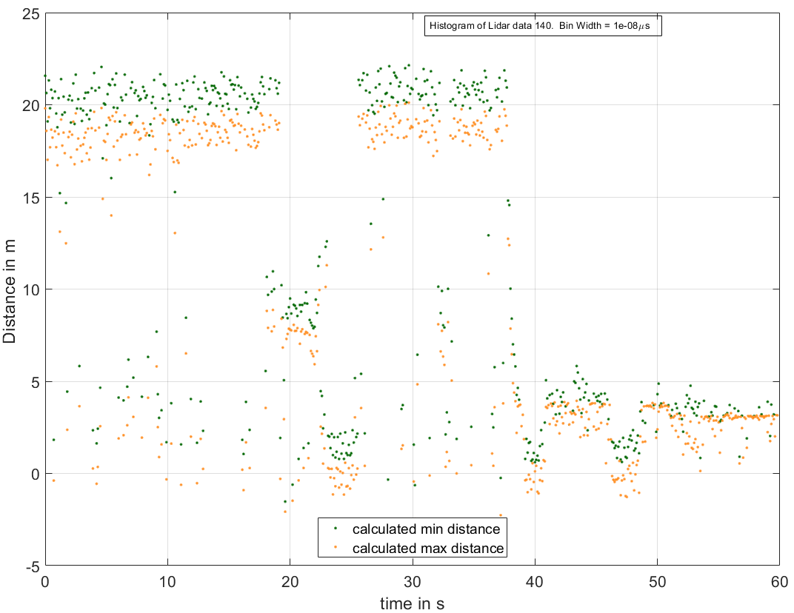

rowsToDelete_low = (Timestamp_ < 0.130); % get rid of lower TOF values

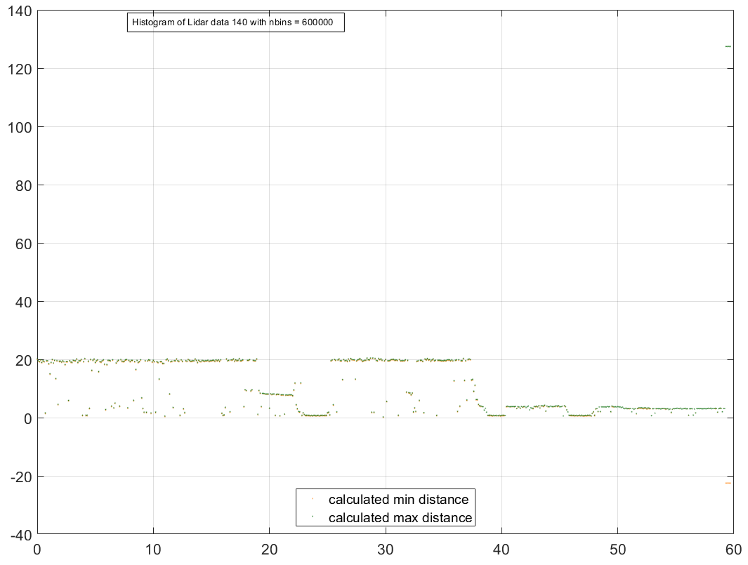

rowsToDelete_low = (Timestamp_ < 0.150); % get rid of lower TOF values

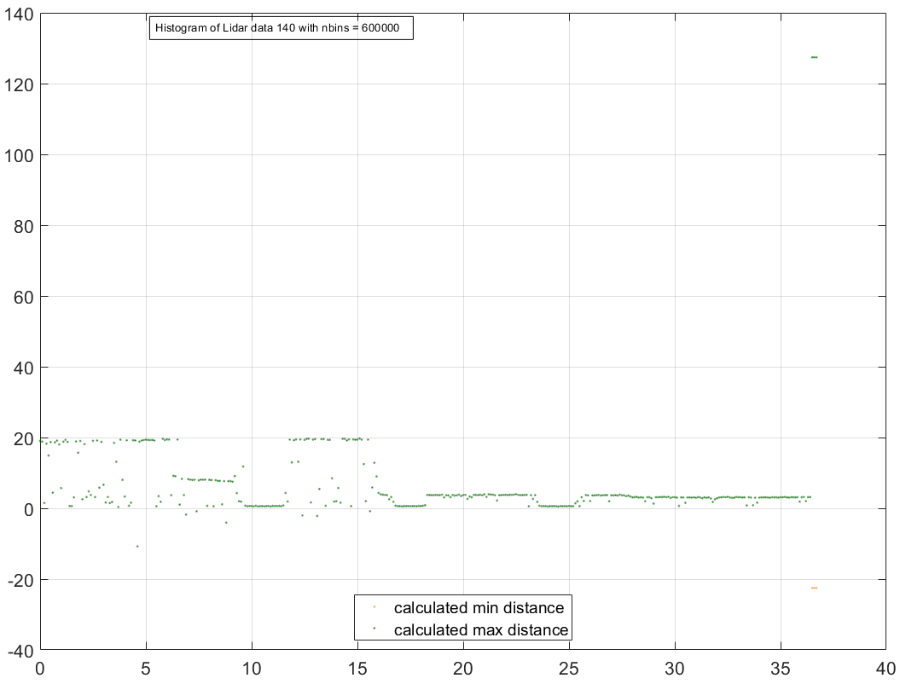

rowsToDelete_high = (Timestamp_ > 0.7); % get rid of higher TOF values

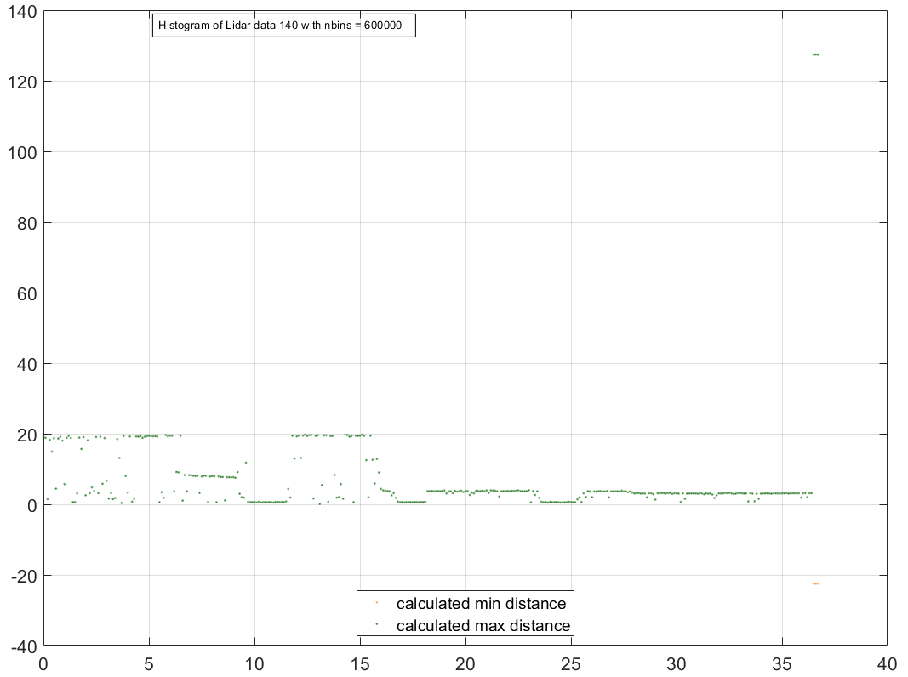

For fix number of nbins we can see the run no matter how much data count we reduce to get rid of too min and max TOF, but for fix Binwidth the run does not proceed.

rowsToDelete_high = (Timestamp_ > 0.7); % get rid of higher TOF values

rowsToDelete_low = (Timestamp_ < 0.150); % get rid of lower TOF values

Wrapping over the histogram and taking the value of multiple peaks:

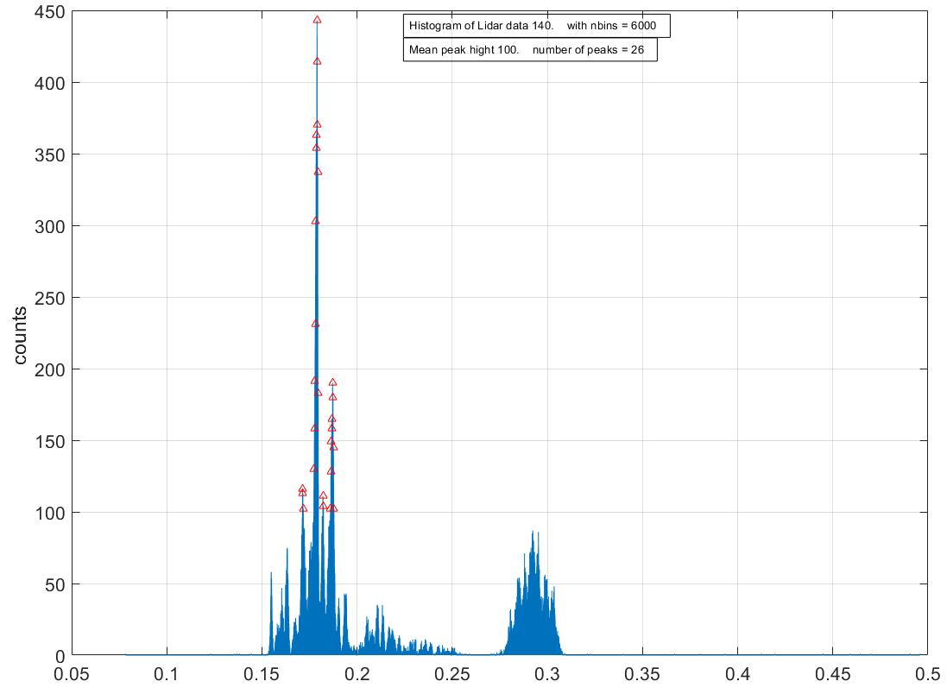

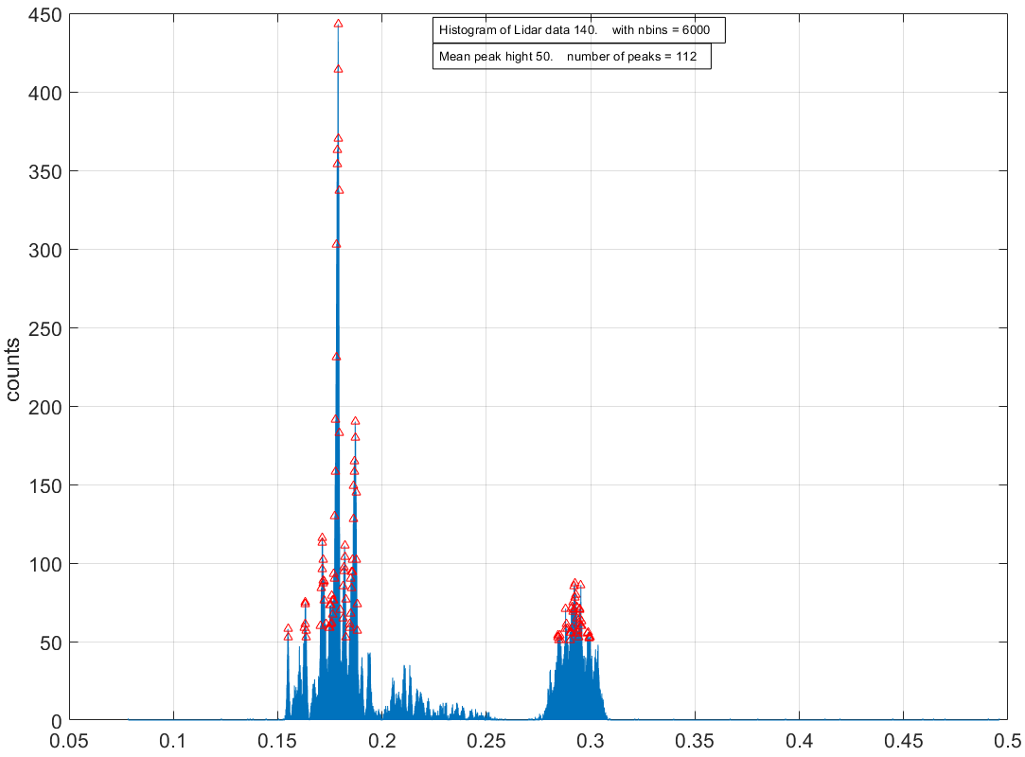

Changing peak height criteria to find peak from multiple target

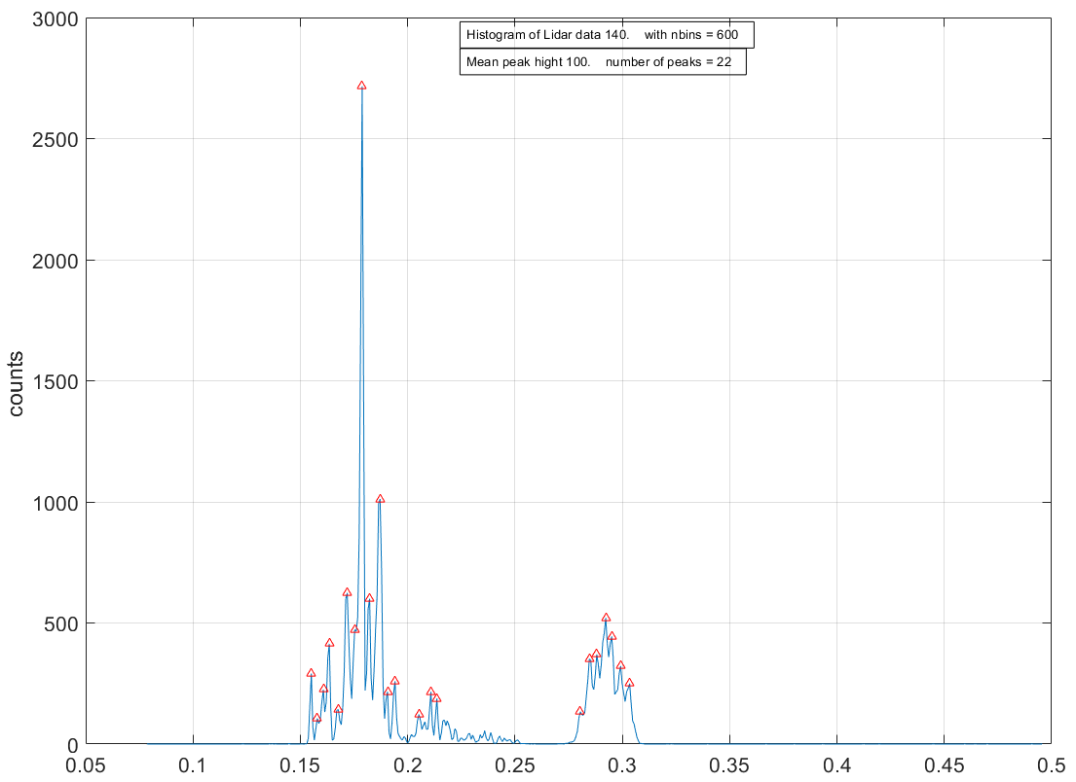

Changing nbins to find peak from multiple target

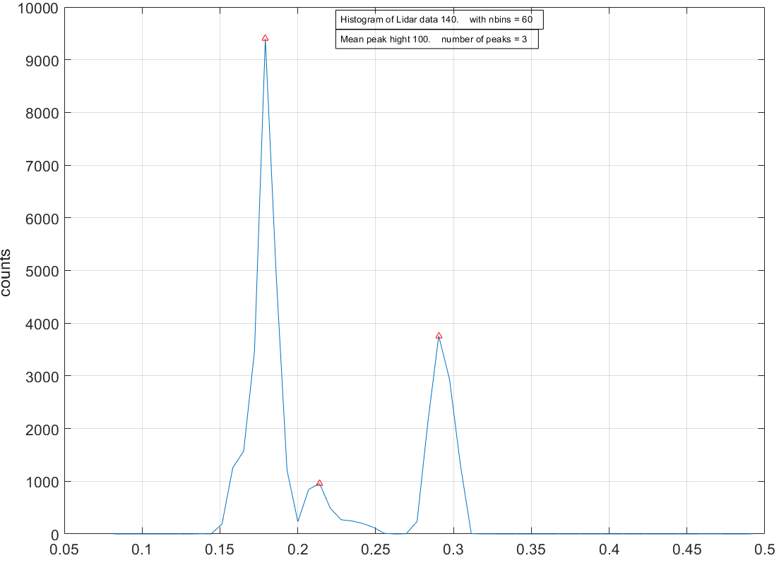

Changing nbins to find peak from multiple target

If in dynamic code this criteria of peak detection is implemented instead of using most probability counts then we able to detect multiple targets which are spatially separated to create 3D point cloud. However the data length will be varying to store in the loop every time it will be little bit complicated in dynamic coding. If we want to number of peaks (number of target) fix for every loop, then that is not practical though we are able to detect multiple target, as the code will automatically adjust prominent target. But if we go for fixed mean peak height (number of counts) then code will be more complicated as variable length in every iteration.